Contact networks of small mammals highlight potential transmission foci of *Mammarenvirus lassaense*.

# Authors

David Simons 1,2,3, Ravi Goyal 4, Umaru Bangura 5,6, Rory Gibb 2,7 Ben Rushton 8, Dianah Sondufu 6, Joyce Lamin 6, James Koninga 9, Momoh Jimmy 9, Mike Dawson 6, Joseph Lahai 6, Rashid Ansumana 6, Elisabeth Fichet-Calvet 5, Richard Kock 1, Deborah Watson-Jones 3,10, Kate E. Jones 2,7

1 Centre for Emerging, Endemic and Exotic Diseases, The Royal Veterinary College, London, United Kingdom

2 Centre for Biodiversity and Environment Research, Department of Genetics, Evolution and Environment, University College London, London, United Kingdom

3 Department of Clinical Research, London School of Hygiene and Tropical Medicine, London, United Kingdom

4 Department of Medicine, University of California, San Diego, USA

6 Implementation Research, Zoonoses control, Bernard-Nocht Institute for Tropical Medicine, Hamburg, Germany

7 Njala University, Bo, Sierra Leone

8 People & Nature Lab, UCL East, Department of Genetics, Evolution and Environment, University College London, London, United Kingdom

9 Panadea Diagnostics GmbH, Hamburg, Germany

10 Kenema Government Hospital, Kenema, Sierra Leone

11 Mwanza Intervention Trials Unit, National Institute for Medical Research, Mwanza, Tanzania

Corresponding author: David Simons, ([dzs6259@psu.edu](mailto:dzs6259@psu.edu)), The Royal Veterinary College, Royal College Street, London, United Kingdom, NW1 0TU, +46793428490

Word count (abstract): 250

Word count (text): 7331

Figures: 5

Tables: 1

Supplementary Information: 1 pdf file

Supplementary Figures: 20 in 1 document

Key words: Rodent associated zoonoses; Mastomys natalensis; Disease ecology; Transmission networks; Land use; Sierra Leone

# Abstract

Lassa fever, caused by *Mammarenavirus lassaense* (LASV), is an endemic zoonosis in several West African countries. Human infections primarily arise from rodent-to-human transmission, with *Mastomys natalensis* , a synanthropic species, serving as the principal reservoir. In Sierra Leone, small-mammal communities vary across land use gradients, potentially shaping LASV transmission risk in human populations. However, the extent to which anthropogenic environments facilitate small-mammal interactions conducive to viral transmission remains poorly understood.

We conducted small-mammal sampling over 43,266 trap nights, detecting 684 rodents and shrews in the LASV-endemic Eastern Province of Sierra Leone. To assess potential for within- and between-species transmission, we constructed space-sharing networks based on co-trapping within species-specific radii informed by home range estimates. These networks approximated shared space use rather than direct interaction, allowing comparison of potential encounter patterns across habitats.

Small-mammal communities in agricultural settings had greater species richness and were more connected than those in villages and forests, although overall space-sharing rates did not differ substantially. Network topology varied by land use, with greater modularity in village networks. Notably, space sharing among *M. natalensis* individuals was more frequent in agricultural settings than in villages, suggesting that land use may modulate opportunities for intra-specific viral transmission.

# LASV seroprevalence across the small-mammal community was 5.7%, with antibodies detected in nine species. We found no major differences in seroprevalence by land use or network complexity. These findings underscore the importance of cross-habitat surveillance to understand host ecology and LASV transmission. Accounting for species-specific space use and habitat-dependent interaction structures is crucial for identifying key hosts and spillover settings.

# Introduction

Lassa fever caused by *Mammarenavirus lassaense* (LASV) is a rodent-associated zoonoses endemic to West Africa, with an estimated 100,000-900,000 infections annually1,2. While outbreaks in Nigeria are routinely reported, cases in other endemic countries - Guinea, Liberia and Sierra Leone - are sporadically documented3–5. In Sierra Leone disease outbreaks frequently go undetected, consistent with findings of up to 80% LASV seropositivity among human communities in regions previously not considered endemic6. Human infections typically result from transmission from rodent hosts, with limited subsequent human-to-human transmission7. Understanding LASV transmission in endemic settings requires a detailed characterization of small-mammal community interactions, through which pathogen transmission occurs and is maintained.

The primary reservoir of LASV, *Mastomys natalensis* is a native synanthropic rodent species, widespread across sub-Saharan Africa. Pathogen challenge studies on *M. natalensis* colonies suggest that acute infection does not significantly alter rodent behaviour or cause clinical pathology8–10. LASV is transmitted through both direct contact (e.g., superficial wounds caused by infected conspecifics) and indirect contact (e.g., exposure to contaminated environments), at low infectious doses9. Vertical transmission (mother-to-pup) may also contribute to transmission dynamics10,11. Infected adult rodents exhibit detectable viral RNA as early as 3 days post-infection, with viral loads peaking within 1-2 weeks and resolving by 40 days9. Among individuals infected within the first 2 weeks of life viral RNA is detectable up to 16-months post infection10. The transient nature of acute infection - outside of neonatal infections - has led many studies to focus on LASV-specific antibody detection, rather than circulating virus12–14.

The antibody response dynamics to LASV in rodents are not yet well understood. Based on data from a similar arenavirus, Morogoro virus, seroconversion is expected to occur by 7 days post-infection, with antibodies (e.g., IgG) persisting beyond the decline of detectable RNA11. LASV-infected rodents are presumed to develop lifelong immunity to reinfection upon seroconversion, however, the efficacy of neutralizing antibodies is unclear and the role of immune or partially immune individuals in transmission networks is not known9,10,15. Although antibody-based studies have limitations, the higher prevalence of LASV seropositivity compared to acute infections provides valuable insights into viral dynamics within endemic regions. For example, a recent study in Bo district, Sierra Leone, reported a 2.8% LASV IgG seroprevalence among rodents and shrews, compared to a 0.3% prevalence of acute infection detected via PCR, underscoring the challenges of identifying acute infections in small-mammal populations16.

While *M. natalensis* is considered the primary reservoir species of LASV, 10 further small-mammal species have been identified as acutely or previously infected with LASV in endemic regions14,17–19. The contribution of these additional species to pathogen transmission into human populations - and their role in viral transmission or maintenance within their species communities - remains unclear. In species-rich environments, both direct and indirect contact among small-mammals may result in incidental infections of non-reservoir species, which are subsequently detected through surveillance. Incidental infections of non-primary reservoir species may have little impact on viral transmission or maintenance20. Alternatively, these species could facilitate the transfer of LASV across landscapes, linking geographically isolated *M. natalensis* populations and causing reintroduction of the virus into reservoir species populations21,22. To account for this uncertainty we refer to *M. natalensis* as the primary reservoir species and other small-mammal species previously found to be infected as hosts. Increasing recognition of multi-species host systems in zoonoses underscores the importance of expanding surveillance efforts to the wider community in which the host resides to better understand pathogen prevalence and dynamics23,24.

Understanding the structure of small-mammal contact networks in LASV-endemic regions may offer valuable insight into transmission potential, even in the absence of direct observations of infection. While prior studies have described rodent diversity and abundance, these do not capture interaction patterns relevant for pathogen spread16,25,26. Spatial proximity can be used as a proxy for potential contact and, when analysed as networks, can help identify structural features, such as connectivity, inter- and intra-specific mixing, and network fragmentation that influence pathogen transmission. In contexts where direct behavioural observation or tagging of individuals is infeasible, such as post-Ebola Sierra Leone, proximity-based approaches provide a pragmatic alternative to infer likely transmission pathways27.

Small-mammal communities in LASV-endemic regions are structured along anthropogenic land use gradients14,28. As such, the risk of Lassa fever outbreaks in human populations is expected to correlate with these gradients6,29,30. Within human-dominated land use types, the prevalence of typically synanthropic rodent hosts of LASV is anticipated to be higher due to increased food availability, shelter, and reduced predation pressure31–33. These factors influence rodent abundance and population dynamics which in turn may promote greater pathogen persistence, as observed in several other rodent-associated zoonosis systems34–36. Understanding how rodent contact networks, like rodent occurrence and abundance, vary along these anthropogenic gradients could reveal potentially distinct pathogen transmission networks in different habitats. We hypothesize that rodent contact rates — and the associated pathogen transmission networks — are greater in human-dominated habitats where resources are concentrated.

In this study, we define “contact” not as a directly observed behavioural interaction between individuals, but as the inferred co-occurrence within a spatial and temporal window (i.e., proximate capture locations within four trap-nights), consistent with prior spatial proximity models37,38. While this does not imply physical contact or indirect contact suitable for transmission, it serves as a proxy for shared habitat use and potential indirect or environmental contact relevant to LASV transmission. Interaction networks derived from wildlife data have previously been employed to study pathogen transmission. These networks are particularly valuable for investigating the role of community structure and the impact of contact rate heterogeneity between species in multi-host pathogen systems39–41.

We leverage rodent and shrew trapping data collected over three years in the Lassa fever-endemic region of the Eastern Province, Sierra Leone. We characterize potential interactions — both direct and indirect — within these communities as a network, where the nodes represent rodents or shrews, and the connections (or edges) between them represent potential interactions. We hypothesize that the spatial clustering of conspecifics and the increased abundance of commensal species in anthropogenically dominated environments will lead to higher intra-specific contact rates compared to inter-specific contact rates within these communities. We use contact rates within and between species to explore their variation along an anthropogenic land use gradient with a particular focus on *M. natalensis*. Finally, we report the prevalence of antibodies against LASV among individual small mammals in the study region and investigate the association between contact rates with seropositivity.

# Methods

## Study area

Rodent trapping surveys were conducted between October 2020-April 2023 within and around four village study sites (Baiama, Lalehun, Lambayama, and Seilama) in the Lassa fever endemic zone of the Eastern Province of Sierra Leone (Figure 1A). Surveys were conducted within trapping grids along a land use gradient of anthropogenic disturbance comprising forest, agriculture (including fallow and currently in-use areas), and villages (within and outside of permanent structures) (see Supplementary Information for study site and trap grid locations). Trapping survey sessions occurred four times annually with two trapping surveys in each of the rainy and dry seasons (May to November and December to April, respectively), producing a total of 10 trapping sessions over the study period.

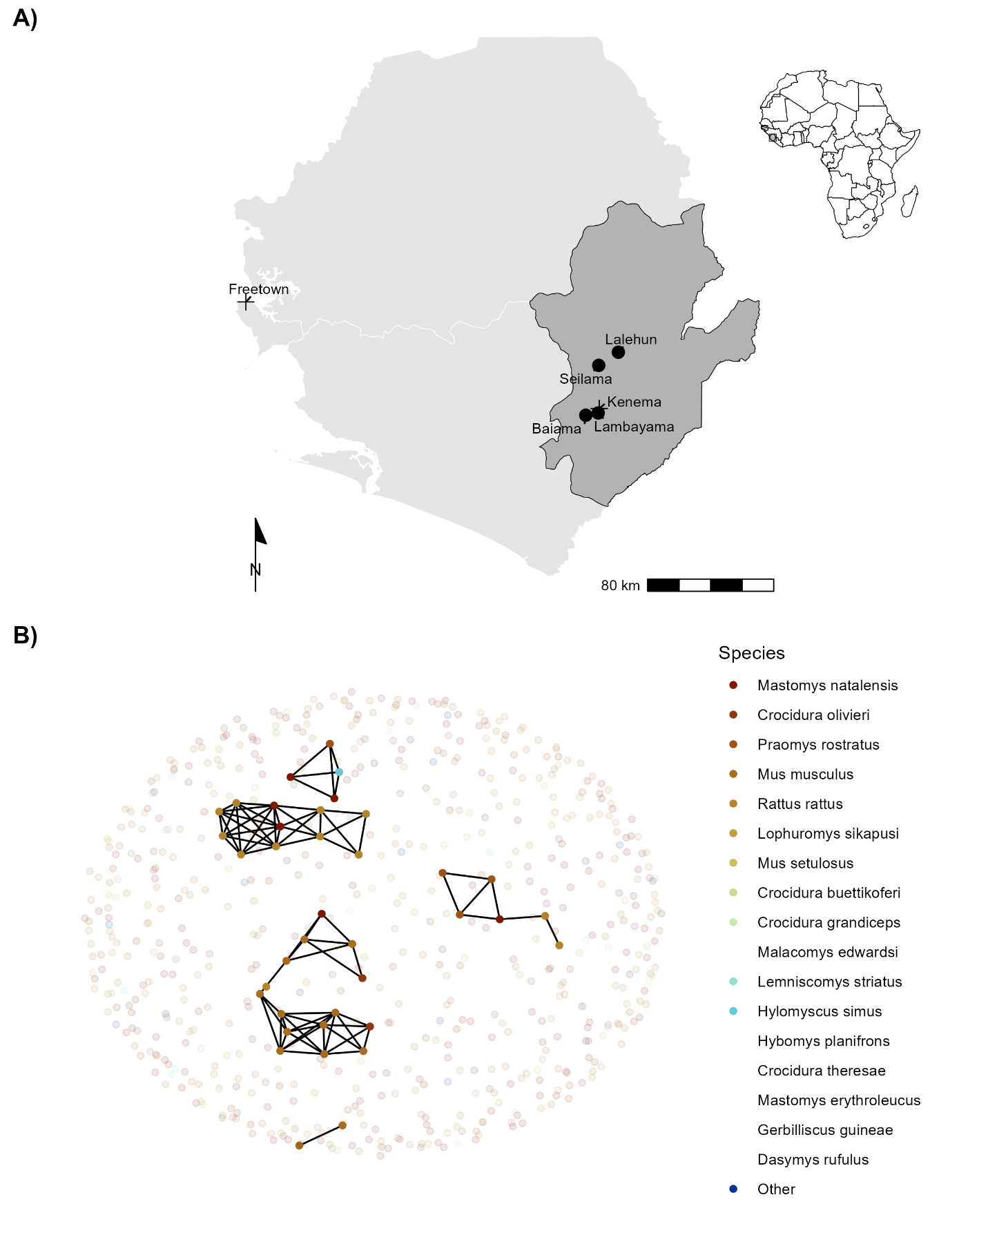Figure 1: A) Location of village study sites (circles) in the Eastern Province of Sierra Leone. Kenema, the largest city in the province, and the national capital, Freetown, are also shown (+). The inset map highlights the location of Sierra Leone within West Africa. B) An example of a rodent contact network derived from trapping data during visit 5 in village land use. Each coloured node represents an individual small mammal, with lines (edges) indicating inferred contacts between individuals. The number of edges connected to a node represents its degree. Betweenness reflects the importance of a node in connecting different parts of the network. Pale nodes indicate unobserved individuals, for whom contacts (edges) were not recorded. Species listed in the legend without colours were never detected in village land use types.

Study sites were selected to represent the range of land use in the Eastern Province of Sierra Leone, considering both accessibility throughout the year and acceptability of the study protocol to the village communities (Supplementary Information). At each trapping grid 49 Sherman traps (7.62cm x 8.89cm x 22.86cm) (H.B. Sherman Traps, Tallahassee, USA), were arranged in a 7 x 7 grid, with traps placed 7 metres apart in a grid conforming to the local landscape (median trapping grid area = 3,882 m2). In permanent structures, trap placement deviated from the grid structure. At each visit, permanent structures were randomly selected from a grid projected over the village area, with four traps placed within each structure. The location of each trap within the grid was geolocated. Traps were baited with a locally produced mixture of oats, palm oil and dried fish. Each morning, traps were checked, closed for the day, and re-baited in the evening. Each trapping survey session consisted of four consecutive trap-nights (TN) at each trapping grid within the village study site. Rodents and shrews were associated with the coordinates of the trap they were detected. Geospatial processing was performed using the sf package R (version 4.1.2)42,43.

All small mammals were handled by trained researchers using appropriate personal protective equipment. Animals were sedated using halothane and euthanized according to established protocols44. Morphological measurements and samples of blood and tissue (skin, liver and spleen) were collected. The study was approved by the Clinical Research Ethical Review Board and Animal Welfare Ethical Review Board of the Royal Veterinary College, UK (URN: 2019 1949-3), and the ethics committee of Njala University, Sierra Leone. The study adhered to national and institutional ethical guidelines for the humane treatment of animals and safe handling of zoonotic pathogens. Trapping and sampling protocols were designed to minimize stress to the animals and reduce the risk of pathogen exposure to researchers and communities. Community engagement sessions were conducted to ensure understanding and acceptance of the study objectives, and all work complied with the principles outlined in the ARRIVE guidelines (v2)45. All carcasses were incinerated to mitigate pathogen transmission risks.

## Species identification

Species identification was performed in the field based on external morphological characteristics, including body length, tail length, ear length, and pelage colouration, following the taxonomic keys of Happold and Kingdon and Monadjem *et al.*46,47. Field identification was supplemented by molecular methods to confirm species identity for individuals identified as *Mastomys sp.*, *Mus sp.*, *Rattus sp.* and *Crocidura sp.* alongside a random subset of remaining individuals (50% of remaining samples).

All samples remained in Sierra Leone and were stored at -20°C until processing. Genomic DNA was extracted using QIAGEN DNAeasy kits as per the manufacturers instructions48 (Supplementary Information). DNA extracts were amplified using platinum *Taq* polymerase (Invitrogen) and *cytochrome B* primers16. DNA amplification was assessed through gel electrophoresis, and successful amplification products were Sanger sequenced (performed by Eurofins Genomics). The sequences were attributed to rodent species using the BLAST program, comparing the obtained sequences to *cytochrome B* records in the NCBI database (accessed 2023-06-30)49.

## LASV seroprevalence

Serological status of trapped rodents and shrews was determined using the BLACKBOX® LASV IgG ELISA Kit (Diagnostics Development Laboratory, Bernhard Nocht Institute for Tropical Medicine), which has been validated for rodent samples50,51. The protocol is reproduced in Supplementary Information. Briefly, 1µL of whole blood was inactivated by mixing with the provided sample dilution buffer (1:50). Where whole blood was unavailable (21 samples, 3%), blood was extracted from dried blood spots stored on filter paper by incubating with phosphate-buffered saline containing 0.08% Sodium Azide and 0.05% Tween-2052. Samples, alongside negative and positive controls, were incubated on the ELISA kit plates for 24 hours at 4-8 °C in a wet chamber. Following incubation, the plates were washed and incubated for a further hour with 1:10,000 diluted HRP-labelled streptavidin. A final wash was performed prior to the addition of 100µL of 3,3’,5,5’-Tetramethylbenzidine (TMB) substrate to wells, with incubation for 10 minutes. The colorimetric reaction was stopped by adding 100µL of a stop solution.

A deviation from the kit protocol occurred due to local ELISA plate reader limitations. We measured the optical density (OD) at 450nm and 630nm, as opposed to 450nm and 620nm but this was not expected to have an important effect on absorbance patterns, as advised by the manufacturer. The index value was calculated by subtracting OD630 from OD450 and dividing by the cut-off value (the mean values of the negative controls + 0.150). Samples were classified as positive if the index value was greater than or equal to 1.1, negative if the index value was less than or equal to 0.9, and inconclusive if the index value was between 0.9 and 1.1. Inconclusive results were retested.

The prevalence of seropositive individuals is reported aggregated by species. A Bayesian logistic regression model was constructed, using the brms package, to estimate the Odds Ratio (OR) of seropositivity for each species compared to *M. natalensis*, which served as the reference species53. Specifically, a Bernoulli regression with normal, uninformative priors for population-level effects was used, with a binary dependent variable for seropositivity and an independent variable of small mammal species. Only species with more than 10 individuals assayed for antibodies to LASV were included in this model. Posterior distributions are presented in graphical format, alongside the posterior mean and 95% Credible Interval (CrI). Unlike frequentist approaches, Bayesian inference does not rely on p-values; rather, statistical support for an effect is assessed based on the posterior distribution, with associations interpreted in terms of the central tendency (e.g., OR) and whether the CrI excludes the null value (OR = 1).

In addition to the species-level seroprevalence analysis, we conducted post-hoc exploratory analyses to assess differences in LASV seroprevalence by village and land use type. These analyses employed Bayesian logistic regression models analogous to those used in species-level comparisons, with results interpreted cautiously given their non-pre-specified nature.

## Small-mammal community

We assessed patterns of small mammal diversity and structure using both rarefaction-based richness estimates and network analysis. To quantify and compare species richness across land use types while accounting for unequal sampling effort, we used individual-based rarefaction (IBR) implemented via the mobr package54,55. Species richness was rarefied to 10 individuals the minimum common sample size across habitats—to provide standardised estimates of alpha diversity for comparison. These rarefied estimates were also evaluated against null models of species abundance distributions to assess deviations from expected patterns under random community assembly.

Species space-sharing networks were reconstructed from the trapping data. Capture-mark-recapture (CMR) methods have previously been used to identify space-sharing by individuals38,56,57. In our study system, a CMR design was not feasible due to study communities concerns around the risk of releasing an infected animal. Therefore, we considered that spatial and temporal co-occurrence proxies direct or indirect contacts with other small-mammals37. We assumed these potential contacts were sufficient to transmit LASV if they were trapped within a species specific buffer zone centered on the location of the trap during the same 4 trap night session. A key assumption underlying this approach is that an individual was trapped at the center of their home range57.

We obtained species specific buffer radii for the primary analysis using the HomeRange R package (version 1.0.2)58. Five rodent species from our study system had available home range data: *M. natalensis* (median home range radii = 10.6m), *Mus musculus* (9.6m), *Lemnisomys striatus* (8m), *Lophuromys sikapusi* (8.4m), and *Rattus rattus* (29.3m). For detected species with no species level home range data, *Praomys rostratus* (7.2m), *Mus setulosus* (9.6m), *Crocidura spp* (7.2m) and *Hylomyscus simus* (7.7m) we used the genus level median home range. For the sole species with no available home range data, *Malacomys edwardsi* we used a conservative estimate of 17m. We further assessed the impact of this assumption on produced contact networks by performing pre-specified sensitivity analyses with buffer radii of 15, 30 and 50 meters.

Networks were constructed from observed animals (nodes) and the presence or absence of contact between them (edges). Data were aggregated by land use type and sampling visit, producing a potential 32 distinct networks from 201 trapping grid, village and visit combinations (see Figure 1B for an example network). However, as no rodents were detected in three networks derived from forest sites, only 29 networks were used in subsequent analysis.

We first explored the properties of these networks, stratified by land use type, the number of nodes (number of individual animals), the number of edges (number of contacts between individual animals), mean node degree (i.e., the mean number of connections to other nodes for each animal), and mean betweenness centrality (i.e., the mean number of times a node lies on the shortest path between other nodes). Descriptions of degree were reported at the global (i.e., network-level) and node-level. We then describe the contact networks stratified by small mammal species, reporting the degree distribution of contacts by species and investigating differences across the land use gradient. Finally, we explore the species-level network characteristics by reporting the proportion of contacts each species has with other species (i.e., the proportion of total inter- and intra-specific contacts) stratified by land use.

## Modelling the probablity of inter- and intra-specific contact rates in *Mastomys natalensis* across a land use gradient

To examine the association between land use and species with the probability of a contact between two individuals, we modelled these contacts using Exponential-Family Random Graph Models (ERGMs)59. The analysis was limited to *M. natalensis*, the primary rodent host of LASV. Estimation of ERGM parameters provide an OR for the probability of an edge in a network – conditional on the rest of the network - based on network properties included in the model and nodal attributes. Within our trapping grids, only a subset of all individuals are detected in traps. Including unobserved individuals — and thus, unobserved contacts — enhances the interpretability and generalizability of the network models. This approach allows for a more accurate estimation of the total population size by accounting for missing data, thereby making the network models more representative of the entire population from which the analytic sample was derived.

### Incorporating unobserved individuals for modelling inter- and intra-specific *Mastomys natalensis* contacts

Previous analysis of our study system suggests that the probability of detecting a rodent at each trap is less than 10% for 4 trap nights, provided that the species is present in the trapping grid28. To estimate the abundance of individuals of each species within a trapping grid, we modelled abundance (i.e., total population size) from repeated count data using an N-mixture model implemented in the unmarked R package (version 1.2.5)60,61. The latent abundance distribution was modelled using Poisson, negative binomial or zero-inflated Poisson random variables. The abundance model included the number of trap nights and season as replicate-dependent detection covariates, as well as location (rural vs. peri-urban setting) and land use type (forest, agriculture or village) as occurrence covariates.

To select the most appropriate model for each species, we compared the Akaike Information Criterion (AIC) of the Poisson, negative binomial, and zero-inflated Poisson models. The best-fitting model was then used to derive the estimated abundance. The median estimated abundance from the distribution produced for each trapping grid was used to estimate the number of unobserved individuals in each network, aggregated by land use type (Supplementary Figures 2.1-2.12). The number of observed individuals was subtracted from the predicted abundance to derive the number of unobserved individuals for each species. These unobserved individuals were explicitly set to have missing (i.e., unobserved) edge values.

Finally, the constructed adjacency matrices were converted to networks using the network R package (version 1.13.0.1) for subsequent ERGM modelling62 (Figure 1B) and Supplementary Figures 3.1-3.3).

### Network models to estimate the probability of inter- and intra-specific contact rates

ERGMs were specified for each of our inferred contact networks to compare the probabilities of edges forming based on rodent characteristics (i.e., species). The general model is shown in Equation 1:

$$\text{P}\left(\text{Y}=\text{y}\right)∝exp\left(θ_{1}g_{1}\left(\text{y}\right)+θ_{2}g_{2}\left(\text{y}\right)+...+θ_{p}g_{p}\left(\text{y}\right)\right) \left(1\right)$$

Where $p$ is the number of terms in the model, and the values of the coefficients $θ$ represent the size and direction of the effects of the covariates $g\left(\text{y}\right)$ on the overall probability of an edge being present in the network. At the edge level the expression for the probability of the entire graph can be re-expressed as the conditional log-odds of a single edge between two nodes (a contact between two rodents) as shown in Equation 2.

$$logit\left(\text{P}\left({\text{Y}}_{ij}=1|{\text{y}}_{ij}^{c}\right)\right)=θ'δ\left({\text{y}}_{ij}\right) \left(2\right)$$

Where ${\text{Y}}_{ij}$ is the random variable for the state of the node pair $ij$ and $y_{i,j}^{c}$ signifies all dyads in the network other than $y_{i,j}$. $θ'$ is the coefficient for the change production of an edge between the two nodes conditional on all other dyads remaining the same ($δ\left({\text{y}}_{ij}\right)$).

ERGMs are implemented using the ergm package (version 4.3.2) in R63. Three terms were included in the final ERGM to model the probability of the formation of ties (Equation 3). The first term (edges), describes the density of the network, representing the probability of a tie being observed in the network. The second term (species) represents the conditional probability of a tie forming, conditional on the species of the nodes. The third term (species homophily) accounts for intraspecific tie formation among rodent individuals (i.e., the conditional probability of two individuals of the same species forming a tie). To reduce linear dependency of the nodal terms and due to data sparsity within our inferred networks all non-*M. natalensis* are grouped as “Other species” through the levels term of the nodal covariates for the analysis of the effect of land use on the probability of inter- or intra-specific contacts for *M. natalensis*.

$$\text{P}\left(\text{Y}=\text{y}\right)∝exp\left(θ_{\text{edges}}g_{\text{edges}}\left(\text{y}\right)+θ_{\text{species}}g_{\text{species}}\left(\text{y}\right)+θ_{\text{homophily}}g_{\text{homophily}}\left(\text{y}\right)\right) \left(3\right)$$

ERGMs were implemented on the individual networks for each land use type at each visit. The effect sizes from each model were pooled through random-effects meta-analysis, stratified by land use, to produce a land use-specific summary effect size for each coefficient64. Inclusion in meta-analysis was restricted to ERGMs that produced stable estimates for each of the model terms (i.e., sufficient detections of *M. natalensis* within the network). Random-effects models were conducted using the metafor package (version 4.0.0) in R65. Heterogeneity across the models was assessed using the $Q$-test and the restricted maximum-likelihood estimator ($τ^{2}$) with a prediction interval for the true outcomes produced64,66. The $Q$-test assesses whether there is greater variability among effect sizes than expected by chance, with a significant result indicating substantial heterogeneity. The $τ^{2}$ statistic estimates the between-study variance, quantifying the degree of heterogeneity rather than just testing for its presence. Weights for each network included in meta-analysis were assigned using inverse-variance weights67.

The presence of influential networks was assessed using Cook’s distance, for models including influential networks leave-one-out sensitivity analysis were performed68. Forest plots were generated to visualize the summary OR of the probability of a tie for each model term, stratified by land use type.

Models with unstable estimates for the species homophily term were not included in the random-effects meta-analysis. No contact networks from forest land use contributed to meta-analysis as no *M. natalensis* were detected in these settings. Five models from agricultural settings and eight from village settings were included in meta-analysis.

## Association of LASV seropositivity and interactions within a small-mammal community network

To investigate pathogen transmission within our networks, using seropositivity as a proxy for prior exposure to LASV, we first report the small-mammal species found to contain individuals that were seropositive for LASV. We then compared the nodal degree of seropositive and seronegative individuals using a Wilcoxon rank-sum test with continuity correction69. This analysis was repeated stratified by species to assess whether contact rates were associated with an individual being seropositive. Finally, we compared the node-level betweenness of seropositive and seronegative individuals to determine whether an individual’s position within a structured contact network was associated with prior exposure to LASV.

## Association intra-specific network clustering and LASV seropositivity in *Mastomys natalensis*

To explore whether the probability of LASV seropositivity in *M. natalensis* was associated with the species composition of their shared-space network, we assessed intra-specific homophily scores using the set of ERGM-derived networks described above that contained at least one seropositive *M. natalensis*. For each of these we generated 50 network simulations. We then calculated, for each *M. natalensis* node, the proportion of observed neighbours that were conspecifics, representing a node-level homophily score ranging from 0 (all observed contacts were with other species) to 1 (all observed contacts were with *M. natalensis*).

To assess the association between homophily and LASV serostatus, we fitted a Bayesian generalised linear mixed-effects model using the brms package. The outcome variable was LASV serostatus, and fixed effects included the homophily score, the node’s degree and an interaction between homophily and degree. To account for the nested structure of the data, random intercepts were included for both the originating network and the simulation replicate. The posterior distribution of model coefficients was used to assess evidence for an association between intra-specific contact clustering and seropositivity.

# Results

A total of 684 small mammals were captured over 43,266 trap-nights, representing 17 species (13 rodent and 4 shrew species). *M. natalensis* was the most commonly detected species (N = 113, 16.5%), followed by *Crocidura olivieri* (N = 105, 15.3%) and *Praomys rostratus* (N = 102, 15%) (Table 1). Rarefied species richness, standardised to 10 individuals using individual-based rarefaction (IBR), was highest in agricultural habitats (*S* = 5.86), intermediate in forest (*S* = 5.13), and lowest in village settings (*S* = 4.36).

Observed richness showed a similar pattern, ranging from 6 species in forest, to 9 in villages, and 12 in agricultural sites. In village habitats, rarefied richness values were consistently lower than expected under null models of species abundance distributions, suggesting reduced evenness and potential dominance effects of synanthropic small mammal species in these settings.

## Prevalence of LASV antibodies within small-mammal communities

Antibodies to LASV were identified in 39 rodents and shrews (39/684, 5.7%) from 9 species, including *M. natalensis* (11/39, 28%), *C. olivieri* (8/39, 21%), *Lophuromys sikapusi* (8/39, 21%) and *Rattus rattus* (4/39, 10%) (Table 1).

Compared to the primary reservoir of LASV (*M. natalensis*), the likelihood of LASV seropositivity was higher in *L. sikapusi* (OR = 2.09, 95% Credible Interval (CrI) = 0.86-4.78) but with wide credible intervals suggesting uncertainty in this result (Figure 2). There was weaker evidence for increased seropositivity in the sole positive shrew species *C. olivieri* (OR = 1.15, 95% CrI = 0.47-2.66). In contrast *M. musculus* (OR = -0.31, 95% CrI = 0.22-0.057) and *P. rostratus* (OR = 0.39, 95% CrI = 0.13-1.11) were less likely to be positive for antibodies against LASV than *M. natalensis*. Wide posterior distributions in this analysis reflect the overall low antibody prevalence, relatively small sample sizes, and uninformative priors used in the model.

Table 1 provides the number of individuals tested and seroprevalence of LASV antibodies by species, while Figure 2 illustrates the odds ratios of seropositivty for species with sufficient sample sizes compared to *M. natalensis*.

Table 1: The number of individuals detected and antibodies to LASV among those individuals.

| Species | Order | Individuals (N) | LASV Antibody detected (%) | Percentage of all positive individuals | OR (95% CrI) |
| --- | --- | --- | --- | --- | --- |
| *Mastomys natalensis* | Rodentia | 113 | 11 (9.7%) | 28.2% | ref |
| *Crocidura olivieri* | Eulipotyphla | 105 | 8 (7.6%) | 20.5% | 1.15 (0.47-2.66) |
| *Praomys rostratus* | Rodentia | 102 | 2 (2%) | 5.1% | 0.39 (0.13-1.11) |
| *Mus musculus* | Rodentia | 90 | 0 (0%) | 0% | 0.22 (0.06-0.73) |
| *Rattus rattus* | Rodentia | 88 | 4 (4.5%) | 10.3% | 0.73 (0.27-1.85) |
| *Lophuromys sikapusi* | Rodentia | 57 | 8 (14%) | 20.5% | 2.09 (0.86-4.78) |
| *Mus setulosus* | Rodentia | 43 | 3 (7%) | 7.7% | 1.01 (0.31-2.96) |
| *Crocidura buettikoferi* | Eulipotyphla | 23 | 0 (0%) | 0% | 0.44 (0.09-1.78) |
| *Crocidura grandiceps* | Eulipotyphla | 15 | 0 (0%) | 0% | 0.51 (0.1-2.33) |
| *Malacomys edwardsi* | Rodentia | 11 | 1 (9.1%) | 2.6% | 1.08 (0.22-4.55) |
| *Lemniscomys striatus* | Rodentia | 11 | 0 (0%) | 0% | 0.59 (0.11-2.68) |
| *Hylomyscus simus* | Rodentia | 9 | 0 (0%) | 0% |  |
| *Hybomys planifrons* | Rodentia | 7 | 1 (14.3%) | 2.6% |  |
| *Mastomys erythroleucus* | Rodentia | 4 | 1 (25%) | 2.6% |  |
| *Crocidura theresae* | Eulipotyphla | 3 | 0 (0%) | 0% |  |
| *Gerbilliscus guineae* | Rodentia | 2 | 0 (0%) | 0% |  |
| *Dasymys rufulus* | Rodentia | 1 | 0 (0%) | 0% |  |

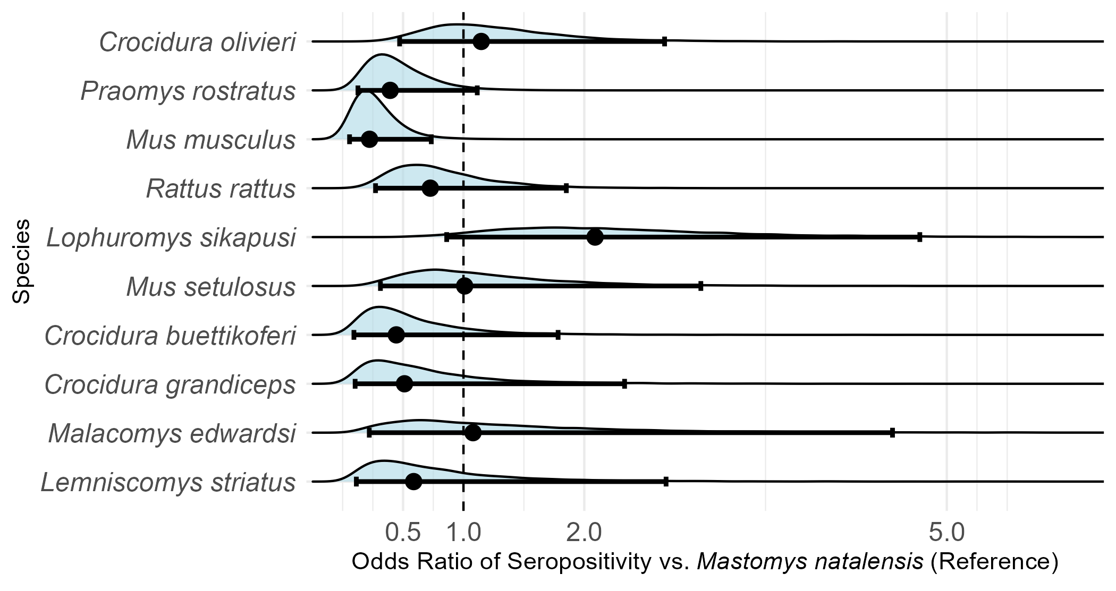

Figure 2: Odds Ratios of seropositivity to LASV among small-mammal species, compared to Mastomys natalensis. Only species with more than 10 individuals assayed for antibodies to LASV were included in this analysis.

Small mammals with antibodies to LASV were detected in three of the study villages, Lalehun (N = 18, 46%), Seilama (N = 12, 31%) and Baiama (N = 9, 23%). Lalehun had the highest percentage of antibody positive rodents (18/157, 12%), followed by Baiama (9/121, 7%) and Seilama (12/263, 5%). No positive individuals were detected in Lambayama, the most urbanised village study site, suggesting a potential association between lower seroprevalence and urban settings. Antibody positive individuals were detected during all study visits except visit 9 (2023-February).

Antibody positive small mammals were detected in all land use types. The proportion of antibody positive individuals among all small mammals trapped were similar across forest (2/44, 4.5%), agricultural (24/379, 6.3%) and village (13/261, 5%) land use types.

In exploratory analyses conducted post hoc, we observed potential differences in LASV seroprevalence by village and land use type accounting for differences in sampling effort. While these analyses were not pre-specified and should be interpreted with caution, seroprevalence appeared to be higher in Lalehun (OR = 2.56, 95% CrI = 1.27-5.27) and Baiama (OR = 1.57, 95% CrI = 0.67-3.52), than the more urbanised village Lambayama (OR = 0.21, 95% CrI = 0.06-0.68), with Seilama set as the reference village. Similarly, agricultural land use (OR = 1.27, 95% CrI = 0.66-2.5) showed the highest proportion of LASV antibody-positive small mammals, with lower seroprevalence observed in forest settings (OR = 0.85, 95% CrI = 0.24-2.71) compared to the reference land use type of village. Credible intervals for the OR of seropositivity with land use crossed an OR of 1 and were therefore not considered importantly different.

## Small-mammal community contact networks

The number of individuals (nodes) was highest in agricultural settings (n = 379) compared to villages (n = 261) and forests (n = 44). Networks in village settings exhibited the highest overall connectivity, as indicated by the highest mean degree (mean = 3.4, standard deviation (SD) = 3.6), followed by agricultural (mean = 1.9, SD = 2.3) and forest settings (mean = 1.4, SD = 1.2).

Additionally, maximum degree values - indicating individuals with the greatest number of direct connections - were observed in village (degree = 14) and agricultural (degree = 13) settings. This suggests that while villages had the highest overall connectivity, certain individuals in agricultural settings acted as highly connected hubs within their networks.

Mean betweenness centrality was highest in agricultural (mean = 1.4, SD = 8.1) and forest (mean = 1.4, SD = 4.7) settings, and lowest in villages (mean = 0.9, SD = 3.3), suggesting that animals in more human-modified environments were less likely to act as bridges connecting otherwise separate parts of the network.

Degree centrality varied across species, with the highest values typically observed in species more common in agricultural settings. Native rodent species *L. sikapusi*, *M. setulosus*, *P. rostratus*, and the shrew *C. olivieri* had individuals with degrees up to 13, though most were lower values (Figure 3). In villages, the invasive synanthropes *M. musculus* and *R. rattus* reached maximum degrees of 14 and 11 with high mean degrees (4.1 and 4.7 respectively). By contrast, *M. natalensis*, though abundant in both agricultural and village settings, had lower maximum degree (8 in villages, 6 in agriculture) and similar mean values (2.3 and 1.8, respectively).

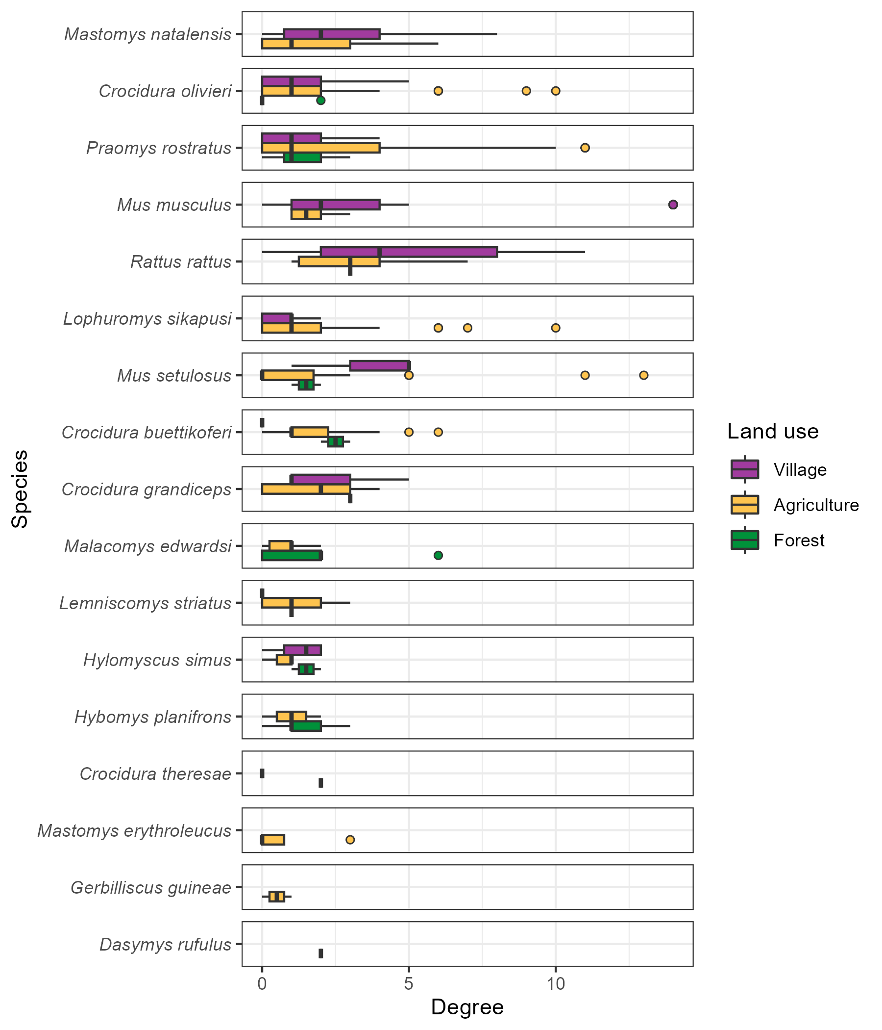

Figure 3: The degree (number of contacts) of individual small mammals stratified by species and land use type. Boxes contain the median and inter-quartile range of the degree distribution. Whiskers include the upper and lower quartile with outliers shown as points.

No consistent trend in degree centrality was observed across all species when stratified by land use type (Figure 3). For commensal species such as *M. natalensis*, *R. rattus* and *M. musculus* the median degree centrality was elevated in villages. However, for *M. natalensis* and *R. rattus*, no statistically significant differences were detected in degree distributions when stratified by land use.

## Describing inter- and intra-specific contact within small mammal communities

Species with more detected individuals generally exhibited a greater number of inter-specific contacts (*r* = 0.73, *p* < 0.001, *n* = 15, Pearson correlation). For instance, the frequently detected species, *M. natalensis*, *P. rostratus* and *R. rattus* each had contacts with more than 11 other species. An exception to this trend was *M. musculus*, which, despite being the fourth most frequently detected species, only had observed contacts with four other species (Figure 4 and Supplementary Figures 4.1 and 4.2).

Intra-specific contacts were common for most species, but notable differences emerged across land use types. For example, *M. natalensis* interacted with 12 other species in agricultural land use settings, with 45% of all observed contacts involving other individuals of the same species (Figure 3). However, in village settings, where *M. natalensis* interacted with fewer species (9), the proportion of intra-specific contacts decreased to 31% (Supplementary Figure 4.2). Not all species showed a dominance of intra-specific contacts. For example, in agricultural areas, *L. sikapusi* interacted with 11 other species. However, a similar proportion of contacts for this species came from *P. rostratus* (27%) as from other individuals of *L. sikapusi* (26%).

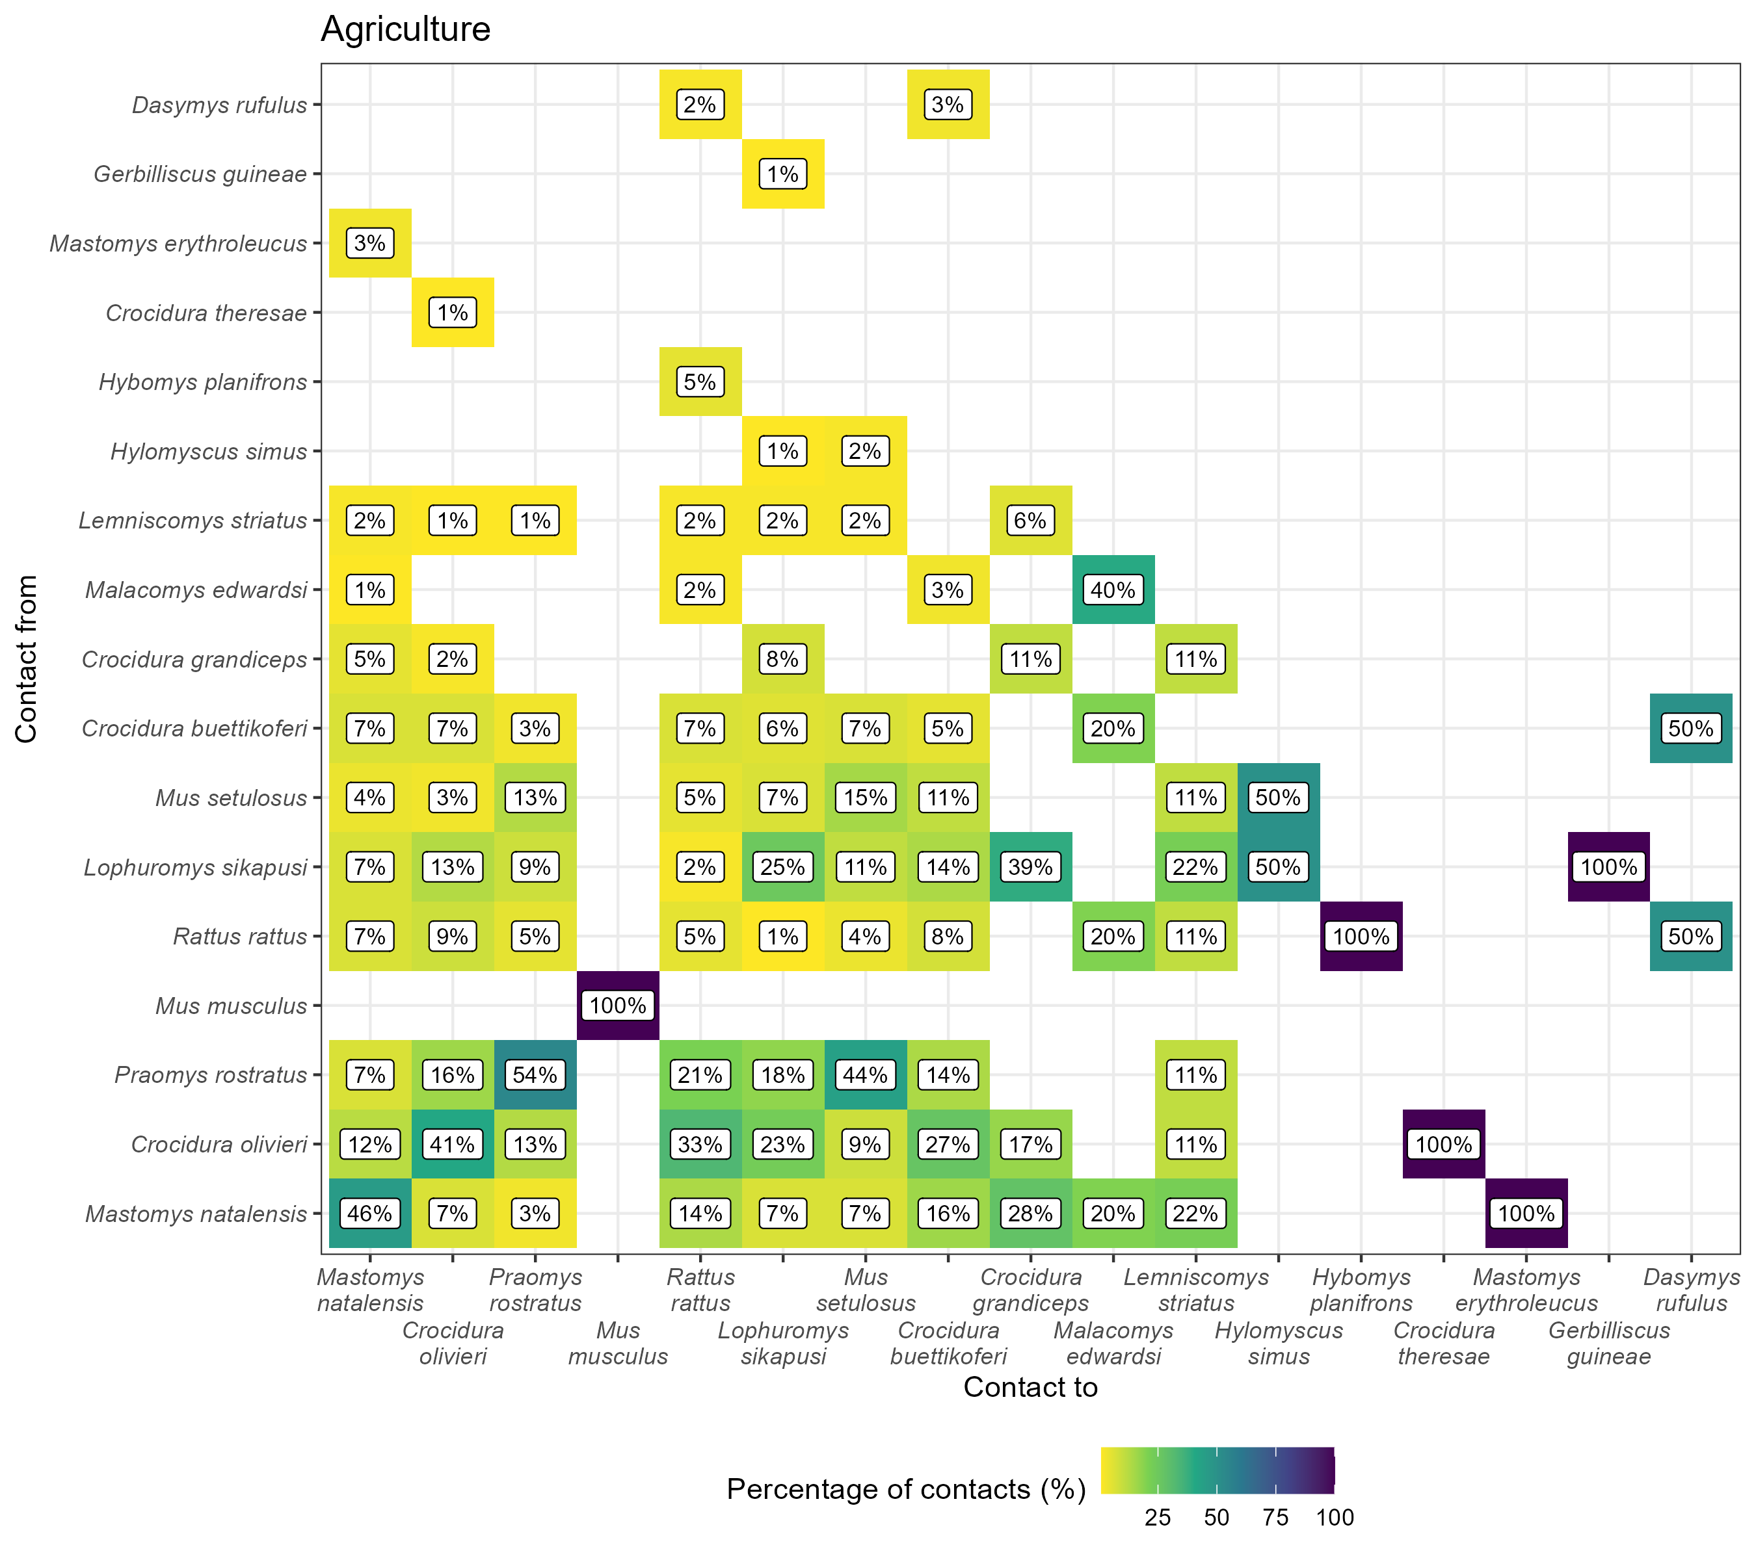

Figure 4: The proportion of contacts between individual small mammals in agricultural land use. Darker colours indicate increasing proportions of observed contacts to a species (Contact to) from named species (Contact from). Numbers in the cells correspond to the proportion of contacts to a species from a named species. For example, 45% of all contacts to Mastomys natalensis are from other M. natalensis while 9% of contacts are from Lophuromys sikapusi. Percentages sum to 100% in the Contact to axis, while they may exceed 100% in Contact from. Species are ordered by the total number detected in this study with M. natalensis (N = 113) in the bottom left.

## The probability of inter- and intraspecific contact rates of *Mastomys natalensis* across a land use gradient

Focusing on the reservoir species of LASV, *M. natalensis*, we analysed the probability of contact using 11 ERGM models (6/10 village networks, 5/10 agricultural networks), which were deemed suitable for random-effects meta-analysis. The odds of an edge being observed for *M. natalensis* were low compared to all potential edges (observed and unobserved edges) and similar across both agricultural (Odds Ratio = 0.05, 95% Confidence Interval = 0.03-0.07, *p* < 0.001) and village land use (OR = 0.15, 95% C.I. = 0.09-0.23, *p* < 0.001) (Figure 5A). There was substantial heterogeneity in odds between networks across different visits for both land use types ( ${\hat{τ}}_{\text{agriculture}}^{2}$ = 0.21, $Q$ = 38, *p* < 0.001 and ${\hat{τ}}_{\text{village}}^{2}$ = 0.29, $Q$ = 35, *p* < 0.001). Compared to other rodent species *M. natalensis* was observed to form fewer contacts overall.

When examining inter-specific space-sharing, *M. natalensis* showed a reduced odds of interacting with other species in village settings (OR = 0.49, 95% C.I. = 0.33-0.73, *p* < 0.001) and a marginally reduced non-statistically significant odds in agricultural settings (OR = 0.6, 95% C.I. = 0.33-1.08, *p* = 0.089) compared to inter-specific contacts among other rodent species (Figure 5B). There was no substantial heterogeneity in inter-specific contact odds between networks ( ${\hat{τ}}_{\text{agriculture}}^{2}$ = 0.22, $Q$ = 8.5, *p* = 0.07 and ${\hat{τ}}_{\text{village}}^{2}$ = 0.09, $Q$ = 8, *p* = 0.15).

Conversely, *M. natalensis* showed a statistically significantly increase in the odds of intra-specific space-sharing in agricultural settings (OR = 5.14, 95% C.I. = 2.17-12.2, *p* < 0.001), but not in village settings (OR = 1.96, 95% C.I. = 0.79-4.82, *p* = 0.15) (Figure 5C). Heterogeneity in intra-specific contact odds was low in both land use types ( ${\hat{τ}}_{\text{agriculture}}^{2}$ = 0, $Q$ = 2.6, *p* = 0.63 and ${\hat{τ}}_{\text{village}}^{2}$ = 0.14, $Q$ = 6, *p* = 0.3). These findings suggest that *M. natalensis* was statistically significantly more likely to engage in intra-specific space-sharing in agricultural settings compared to other small mammals but not in villages.

Sensitivity analyses revealed no changes in the direction of effect sizes when altering the contact radius although the magnitude of the effect sizes varied (Supplementary Figures 5.1 and 5.2). Additionally, leave-one-out sensitivity analyses for influential networks did not indicate meaningful changes in the effect size magnitude or direction. These results support the robustness of the findings across space-sharing buffer area assumptions and community composition changes across visits.

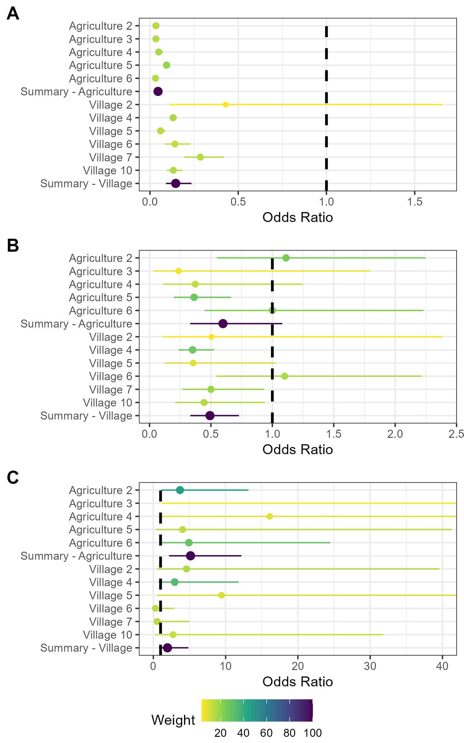

Figure 5: Random effects meta-analysis of ERGM network models reporting the odds of a contact being observed for M natalensis. A) The odds ratio of a contact being observed for M. natalensis in Agricultural or Village land use types. B) The odds ratio of a contact being observed between M. natalensis and an individual of a different rodent species. C) The odds ratio of a contact being observed between M. natalensis and another M. natalensis.

## Association of LASV seropositivity and position within a small-mammal community contact network

Rodents and shrews that were LASV seropositive had a significantly lower mean degree centrality (mean = 3.7, SD = 2.9) compared to seronegative individuals (mean = 5.5, SD = 5.1) (W = 10018, p = 0.039). Species-specific analyses, performed only for species with more than five seropositive individuals (*M. natalensis*, *L. sikapusi* and *C. olivieri*) showed significantly lower mean degree centrality in seropositive compared to seronegative individuals for *M. natalensis* (W = 354, *p* = 0.048) and *L. sikapusi* (W = 99.5, *p* = 0.03), but not for *C. olivieri* (W = 429.5, *p* = 0.54).

The lower mean degree centrality observed in seropositive individuals suggests that individuals with fewer connections were more likely to be seropositive. Given the low overall seroprevalence, this pattern may reflect limited recent pathogen transmission within the population, potentially due to stochastic transmission events rather than sustained intraspecific transmission.

## Association intra-specific network clustering and LASV seropositivity in *Mastomys natalensis*

In *M. natalensis*, the odds of LASV seropositivity increased with degree (OR = 1.25, 95% CrI: 1.10–1.40), and there was some evidence of a positive association with homophily (OR = 2.02, 95% CrI: 1.00–3.96). However, a strong negative interaction between degree and homophily (OR = 0.52, 95% CrI: 0.40–0.67) suggests that the association between contact number and seropositivity risk was attenuated when a greater proportion of contacts were with conspecifics.

# Discussion

In the Eastern province of Sierra Leone, we found that small-mammal contact networks were generally more densely connected in village and agricultural settings, with higher mean degree in these habitats than in forested ones. However, overall contact rates per individual were comparable across land use types, with most animals having fewer than five contacts, forming sparse networks (mean degree < 3). While degree centrality did not differ systematically by species, *M. natalensis* exhibited a high probability of intra-specific contacts in agricultural settings, suggesting that these areas may serve as focal points for LASV transmission, consistent with findings linking anthropogenic environments to zoonotic disease risk70,71. LASV seropositivity was detected at low prevalence across six rodent and shrew species, with *M. natalensis* comprising most seropositive individuals. However, seropositive individuals had lower degree centrality overall, though this pattern was not consistent between species.

*A priori*, we hypothesised that individuals with higher degree centrality (i.e., those with greater space-sharing interactions) would be at greater risk of LASV exposure, and that this effect would vary by land use and species. While LASV seropositivity was detected at low prevalence across nine rodent and shrew species, seropositive individuals tended to have lower degree centrality, this pattern was inconsistent and potentially confounded by age or habitat.

Although we hypothesised that contact rates would be higher in anthropogenic habitats, global degree centrality was similar across land use types. However, the upper tail of the degree distribution was skewed towards individuals in villages and agriculture, underscoring the importance of individual-level variation not captured by aggregated metrics72,73. Agricultural areas also exhibited the highest species richness and a greater proportion of inter-specific space-sharing, likely reflecting edge effects that facilitate interactions between synanthropic and sylvatic species74,75. Notably, native species such as *P. rostratus* in agricultural habitats displayed high degree centrality, suggesting that suggesting that a few highly interactive species may disproportionately shape network connectivity and transmission risk31.

Network structure also varied across land use types. Village networks had higher betweenness centrality and modularity, indicating greater structural fragmentation and local clustering, with certain individuals acting as bridges between otherwise unconnected subnetworks. These bridging individuals could play a pivotal role in facilitating or constraining transmission76. Conversely, lower betweenness centrality in agricultural networks indicates more cohesive contact structures, potentially supporting faster or more sustained transmission cycles.

In contrast, we found no consistent difference in betweenness centrality between seropositive and seronegative individuals suggesting that, while seropositive rodents tended to have fewer direct contacts (lower degree), their role in linking network clusters was not markedly different.

The structure of *M. natalensis* interactions also varied by land use. In agricultural settings *M. natalensis* exhibited high intra-specific clustering, whereas in villages, inter-specific space-sharing was more frequent. These patterns are consistent with the species’ weak territoriality10,77–79. This intra-specific homophily in agricultural settings would be expected to support LASV transmission within *M. natalensis* populations, where competent hosts can sustain transmission chains80. In contrast, frequent interspecific contacts in villages may enhance spillover potential, but could dilute within-species transmission chains. Movement between habitats may further further modulate these dynamics81.

These findings suggest that *M. natalensis* may not be the sole driver of LASV transmission. Our exploratory homophily analysis showed that when individuals had relatively few contacts, those with more conspecific interactions (i.e. high homophily) were more likely to be LASV-seropositive. However, as the number of contacts increased, the effect of homophily diminished—meaning that among individuals with many contacts, the species identity of those contacts became less predictive of serological status. This pattern could imply that heterospecific contacts contribute disproportionately to LASV exposure, particularly in more connected individuals, and supports the possibility of broader community-level circulation of LASV. As this analysis was exploratory and based on simulated networks, these findings should be interpreted with caution.

The structure of agricultural networks (i.e., relatively cohesive with high intra-specific connectivity), may support rapid local spread and potential pathogen fadeout if host turnover cannot sustain transmission76,82. In contrast, the more fragmented village networks (i.e., with higher modularity and betweenness) may allow slower transmission and longer-term persistence83. These contrasts suggest interventions should be tailored to land use contexts, particularly given agriculture’s potential role in amplifying transmission.

The seroprevalence of LASV (5.7%), was consistent with prior estimates from Sierra Leone16. Our study included forest sites further from human habitation, yet the proportion of M. natalensis individuals testing positive was similar (~9%). However, *M. natalensis* represented a smaller fraction of total seropositive individuals (28% vs. 75%), and we detected LASV antibodies in additional species (*C. olivieri*, *M. setulosus*, *Hybomys planifrons*, *Mastomys erythroleucus*), suggesting broader host involvement than previously documented16. This finding supports a multi-host perspective on LASV ecology12,18.

Several key assumptions warrant consideration. First, rodent contacts were inferred from co-location in space and time, assuming uniform movement within estimated home ranges—an assumption unlikely to hold across species with variable movement behaviours37,38,57. Real-time tracking (e.g., radio-tagging) could refine these estimates, though ethical challenges exist to conducting these in our study areas84,85. Second, only a subset of active individuals was captured, and behavioural differences between captured and uncaptured animals could bias network inferences and metrics86,87. We partially accounted for this by inferring total species abundance73,88. In addition, removal trapping may have created temporary spatial vacuums later filled by transient individuals with potentially different contact behaviours. Although trapping sessions were spaced by ≥3 months to allow for re-equilibration, as recommended in regional protocols, we cannot exclude bias from altered community composition. While our leave-one-out meta-analysis helps account for spatial hotspots between sessions, it cannot address changes in network structure caused by removal and replacement of high-contact individuals. Replicating the study across more sites would help evaluate these potential biases.

In conclusion, this study highlights the variability in contact rates and network structures among rodent and shrew species across land-use types in LASV-endemic settings. The complex contact networks involving multiple species may facilitate LASV transmission in unexpected ways, particularly in agricultural settings where intra- and inter-specific interactions are frequent. These findings underscore the importance of tailoring control strategies to specific ecological contexts and host species behaviours to mitigate Lassa fever risks effectively.

# References

1. McCormick JB, Webb PA, Krebs JW, Johnson KM, Smith ES., 1987. [A prospective study of the epidemiology and ecology of lassa fever.](https://doi.org/10.1093/infdis/155.3.437) *J Infect Dis* *155*: 437–44

2. Basinski AJ, Fichet-Calvet E, Sjodin AR, Varrelman TJ, Remien CH, Layman NC, Bird BH, Wolking DJ, Monagin C, Ghersi BM, Barry PA, Jarvis MA, Gessler PE, Nuismer SL., 2021. [Bridging the gap: Using reservoir ecology and human serosurveys to estimate lassa virus spillover in west africa](https://doi.org/10.1371/journal.pcbi.1008811). *PLoS Comput Biol* *17*: e1008811

3. Jetoh RW, Malik S, Shobayo B, Taweh F, Yeabah TO, George J, Gbelee B, Teahton J, Jaryan F, Tegli M, Umeokonkwo CD, MaCauley J., 2022. [Epidemiological characteristics of lassa fever cases in liberia: A retrospective analysis of surveillance data, 2019-2020](https://doi.org/10.1016/j.ijid.2022.07.006). *International Journal of Infectious Diseases*

4. Shaffer JG, Schieffelin JS, Momoh M, Goba A, Kanneh L, Alhasan F, Gbakie M, Engel EJ, Bond NG, Hartnett JN, Nelson DKS, Bush DJ, Boisen ML, Heinrich ML, Rowland MM, et al., 2021. [Space-time trends in lassa fever in sierra leone by ELISA serostatus, 2012–2019](https://doi.org/10.3390/microorganisms9030586). *Microorganisms* *9*: 586

5. Bausch DG, Demby AH, Coulibaly M, Kanu J, Goba A, Bah A, Condé N, Wurtzel HL, Cavallaro KF, Lloyd E, Baldet FB, Cissé SD, Fofona D, Savané IK, Tolno RT, et al., 2001. [Lassa fever in guinea: I. Epidemiology of human disease and clinical observations](https://doi.org/10.1089/15303660160025903). *Vector Borne Zoonotic Dis* *1*: 269–281

6. Grant DS, Engel EJ, Yerkes NR, Kanneh L, Koninga J, Gbakie MA, Alhasan F, Kanneh FB, Kanneh IM, Kamara FK, Momoh M, Yillah MS, Foday M, Okoli A, Zeoli A, et al., 2023. [Seroprevalence of anti-lassa virus IgG antibodies in three districts of sierra leone: A cross-sectional, population-based study](https://doi.org/10.1371/journal.pntd.0010938). *PLOS Neglected Tropical Diseases* *17*: e0010938

7. Lo Iacono G, Cunningham AA, Fichet-Calvet E, Garry RF, Grant DS, Khan SH, Leach M, Moses LM, Schieffelin JS, Shaffer JG, Webb CT, Wood JLN., 2015. [Using modelling to disentangle the relative contributions of zoonotic and anthroponotic transmission: The case of lassa fever](https://doi.org/10.1371/journal.pntd.0003398). *PLOS NEGLECTED TROPICAL DISEASES* *9*

8. Walker DH, Wulff H, Lange JV, Murphy FA., 1975. [Comparative pathology of lassa virus infection in monkeys, guinea-pigs, and mastomys natalensis](https://www.ncbi.nlm.nih.gov/pmc/articles/PMC2366626). *Bull World Health Organ* *52*: 523–534

9. Safronetz D, Rosenke K, Meade-White K, Sloan A, Maiga O, Bane S, Martellaro C, Scott DP, Sogoba N, Feldmann H., 2022. [Temporal analysis of lassa virus infection and transmission in experimentally infected mastomys natalensis](https://doi.org/10.1093/pnasnexus/pgac114). *PNAS Nexus* *1*: pgac114

10. Hoffmann C, Krasemann S, Wurr S, Hartmann K, Adam E, Bockholt S, Müller J, Günther S, Oestereich L., 2024. [Lassa virus persistence with high viral titers following experimental infection in its natural reservoir host, Mastomys natalensis](https://doi.org/10.1038/s41467-024-53616-4). *Nature Communications* *15*: 9319

11. Borremans B, Vossen R, Becker-Ziaja B, Gryseels S, Hughes N, Van Gestel M, Van Houtte N, Günther S, Leirs H., 2015. [Shedding dynamics of morogoro virus, an african arenavirus closely related to lassa virus, in its natural reservoir host mastomys natalensis](https://doi.org/10.1038/srep10445). *Sci Rep* *5*: 10445

12. Demby AH, Inapogui A, Kargbo K, Koninga J, Kourouma K, Kanu J, Coulibaly M, Wagoner KD, Ksiazek TG, Peters CJ, Rollin PE, Bausch DG., 2001. [Lassa fever in guinea: II. Distribution and prevalence of lassa virus infection in small mammals](https://doi.org/10.1089/15303660160025912). *Vector-Borne and Zoonotic Diseases* *1*: 283–297

13. Kerneis S, Koivogui L, Magassouba N, Koulemou K, Lewis R, Aplogan A, Grais RF, Guerin PJ, Fichet-Calvet E., 2009. [Prevalence and risk factors of lassa seropositivity in inhabitants of the forest region of guinea: A cross-sectional study](https://doi.org/10.1371/journal.pntd.0000548). *PLoS Neglected Tropical Diseases [electronic resource]* *3*: e548

14. Fichet-Calvet E, Becker-Ziaja B, Koivogui L, Gunther S., 2014. [Lassa serology in natural populations of rodents and horizontal transmission](https://doi.org/10.1089/vbz.2013.1484). *Vector Borne & Zoonotic Diseases* *14*: 665–674

15. Mariën J, Borremans B, Gryseels S, Soropogui B, De Bruyn L, Bongo GN, Becker-Ziaja B, Bellocq JG de, Günther S, Magassouba N, Leirs H, Fichet-Calvet E., 2017. [No measurable adverse effects of lassa, morogoro and gairo arenaviruses on their rodent reservoir host in natural conditions](https://doi.org/10.1186/s13071-017-2146-0). *Parasites & Vectors* *10*: 210

16. Bangura U, Buanie J, Lamin J, Davis C, Bongo GN, Dawson M, Ansumana R, Sondufu D, Thomson EC, Sahr F, Fichet-Calvet E., 2021. [Lassa virus circulation in small mammal populations in bo district, sierra leone](https://doi.org/10.3390/biology10010028). *BIOLOGY-BASEL* *10*

17. Monath TP, Newhouse VF, Kemp GE, Setzer HW, Cacciapuoti A., 1974. [Lassa virus isolation from mastomys natalensis rodents during an epidemic in sierra leone](https://doi.org/10.1126/science.185.4147.263). *Science* *185*: 263–265

18. Olayemi A, Cadar D, Magassouba N, Obadare A, Kourouma F, Oyeyiola A, Fasogbon S, Igbokwe J, Rieger T, Bockholt S, Jérôme H, Schmidt-Chanasit J, Garigliany M, Lorenzen S, Igbahenah F, et al., 2016. [New Hosts of The Lassa Virus](https://doi.org/10.1038/srep25280). *Scientific Reports* *6*: 25280

19. Simons D, Attfield LA, Jones KE, Watson-Jones D, Kock R., 2023. [Rodent trapping studies as an overlooked information source for understanding endemic and novel zoonotic spillover](https://doi.org/10.1371/journal.pntd.0010772). *PLOS Neglected Tropical Diseases* *17*: e0010772

20. Gilbert AT, Fooks AR, Hayman DTS, Horton DL, Müller T, Plowright R, Peel AJ, Bowen R, Wood JLN, Mills J, Cunningham AA, Rupprecht CE., 2013. [Deciphering serology to understand the ecology of infectious diseases in wildlife](https://doi.org/10.1007/s10393-013-0856-0). *EcoHealth* *10*: 298–313

21. Caron A, Cappelle J, Cumming GS, Garine-Wichatitsky M de, Gaidet N., 2015. [Bridge hosts, a missing link for disease ecology in multi-host systems](https://doi.org/10.1186/s13567-015-0217-9). *Veterinary Research* *46*: 83

22. Cardenas NC, Sykes AL, Lopes FPN, Machado G., 2022. [Multiple species animal movements: Network properties, disease dynamics and the impact of targeted control actions](https://doi.org/10.1186/s13567-022-01031-2). *Veterinary Research* *53*: 14

23. Keesing F, Ostfeld RS., 2021. [Impacts of biodiversity and biodiversity loss on zoonotic diseases](https://doi.org/10.1073/pnas.2023540118). *Proceedings of the National Academy of Sciences* *118*: e2023540118

24. Albery GF, Becker DJ, Brierley L, Brook CE, Christofferson RC, Cohen LE, Dallas TA, Eskew EA, Fagre A, Farrell MJ, Glennon E, Guth S, Joseph MB, Mollentze N, Neely BA, et al., 2021. [The science of the host–virus network](https://doi.org/10.1038/s41564-021-00999-5). *Nat Microbiol* *6*: 1483–1492

25. Fichet‐Calvet E, Audenaert L, Barrière P, Verheyen E., 2010. [Diversity, dynamics and reproduction in a community of small mammals in upper guinea, with emphasis on pygmy mice ecology](https://doi.org/10.1111/j.1365-2028.2009.01144.x). *African Journal of Ecology* *48*: 600–614

26. Happi AN, Olumade TJ, Ogunsanya OA, Sijuwola AE, Ogunleye SC, Oguzie JU, Nwofoke C, Ugwu CA, Okoro SJ, Otuh PI, Ngele LN, Ojo OO, Adelabu A, Adeleye RF, Oyejide NE, et al., 2022. [Increased prevalence of lassa fever virus-positive rodents and diversity of infected species found during human lassa fever epidemics in nigeria](https://doi.org/10.1128/spectrum.00366-22). *Microbiol Spectr* *10*: e0036622

27. Rohan H., 2022. [Beyond Lassa Fever: Systemic and structural barriers to disease detection and response in Sierra Leone](https://doi.org/10.1371/journal.pntd.0010423). *PLOS Neglected Tropical Diseases* *16*: e0010423

28. Simons D, Gibb R, Bangura U, Sondufu D, Lamin J, Koninga J, Jimmy M, Dawson M, Lahai J, Ansumana R, Fichet-Calvet E, Watson-Jones D, Kock R, Jones K., 2025. [Land use gradients drive spatial variation in Lassa fever host communities in the Eastern Province of Sierra Leone.](https://doi.org/10.32942/X2N33P)

29. Klitting R, Kafetzopoulou LE, Thiery W, Dudas G, Gryseels S, Kotamarthi A, Vrancken B, Gangavarapu K, Momoh M, Sandi JD, Goba A, Alhasan F, Grant DS, Okogbenin S, Ogbaini-Emovo E, et al., 2022. [Predicting the evolution of the lassa virus endemic area and population at risk over the next decades](https://doi.org/10.1038/s41467-022-33112-3). *Nature communications* *13*: 5596

30. Longet S, Leggio C, Bore JA, Key S, Tipton T, Hall Y, Koundouno FR, Bower H, Bhattacharyya T, Magassouba N, Günther S, Henao-Restrapo A-M, Rossman JS, Konde MK, Fornace K, et al., 2023. [Influence of landscape patterns on exposure to lassa fever virus, guinea](https://doi.org/10.3201/eid2902.212525). *Emerg Infect Dis* *29*: 304–313

31. Gibb R, Redding DW, Chin KQ, Donnelly CA, Blackburn TM, Newbold T, Jones KE., 2020. [Zoonotic host diversity increases in human-dominated ecosystems](https://doi.org/10.1038/s41586-020-2562-8). *Nature* *584*: 398–402

32. Albery GF, Carlson CJ, Cohen LE, Eskew EA, Gibb R, Ryan SJ, Sweeny AR, Becker DJ., 2022. [Urban-adapted mammal species have more known pathogens](https://doi.org/10.1038/s41559-022-01723-0). *Nature Ecology & Evolution* *6*: 794–801

33. Ecke F, Han BA, Hörnfeldt B, Khalil H, Magnusson M, Singh NJ, Ostfeld RS., 2022. [Population fluctuations and synanthropy explain transmission risk in rodent-borne zoonoses](https://doi.org/10.1038/s41467-022-35273-7). *Nat Commun* *13*: 7532

34. Sauvage F, Langlais M, Yoccoz NG, Pontier D., 2003. [Modelling hantavirus in fluctuating populations of bank voles: The role of indirect transmission on virus persistence](https://doi.org/10.1046/j.1365-2656.2003.00675.x). *Journal of Animal Ecology* *72*: 1–13

35. Laverty SM, Adler FR., 2009. [The role of age structure in the persistence of a chronic pathogen in a fluctuating population](https://doi.org/10.1080/17513750802452544). *Journal of Biological Dynamics* *3*: 224–234

36. Salkeld DJ, Salathé M, Stapp P, Jones JH., 2010. [Plague outbreaks in prairie dog populations explained by percolation thresholds of alternate host abundance](https://doi.org/10.1073/pnas.1002826107). *Proceedings of the National Academy of Sciences* *107*: 14247–14250

37. Perkins SE, Cagnacci F, Stradiotto A, Arnoldi D, Hudson PJ., 2009. [Comparison of social networks derived from ecological data: Implications for inferring infectious disease dynamics](https://doi.org/10.1111/j.1365-2656.2009.01557.x). *Journal of Animal Ecology* *78*: 1015–1022

38. Clay CA, Lehmer EM, Previtali A, St. Jeor S, Dearing MD., 2009. [Contact heterogeneity in deer mice: Implications for sin nombre virus transmission](https://doi.org/10.1098/rspb.2008.1693). *Proc Biol Sci* *276*: 1305–1312

39. Böhm M, Hutchings MR, White PCL., 2009. [Contact networks in a wildlife-livestock host community: Identifying high-risk individuals in the transmission of bovine TB among badgers and cattle](https://doi.org/10.1371/journal.pone.0005016). *PLOS ONE* *4*: e5016

40. Drewe JA, Eames KTD, Madden JR, Pearce GP., 2011. [Integrating contact network structure into tuberculosis epidemiology in meerkats in south africa: Implications for control](https://doi.org/10.1016/j.prevetmed.2011.05.006). *Prev Vet Med* *101*: 113–120

41. White LA, Forester JD, Craft ME., 2017. [Using contact networks to explore mechanisms of parasite transmission in wildlife](https://doi.org/10.1111/brv.12236). *Biological Reviews* *92*: 389–409

42. Pebesma E., 2018. [Simple features for r: Standardized support for spatial vector data](https://journal.r-project.org/archive/2018/RJ-2018-009/index.html). *The R Journal* *10*: 439–446

43. R Core Team., 2021. [R: A language and environment for statistical computing](https://www.R-project.org/). Vienna, Austria: R Foundation for Statistical Computing

44. Fichet-Calvet E., 2014. [Chapter 5 - lassa fever: A rodent-human interaction](https://doi.org/10.1016/B978-0-12-405191-1.00005-3). Johnson N, ed. *The role of animals in emerging viral diseases*. Boston: Academic Press, 89–123

45. Percie Du Sert N, Ahluwalia A, Alam S, Avey MT, Baker M, Browne WJ, Clark A, Cuthill IC, Dirnagl U, Emerson M, Garner P, Holgate ST, Howells DW, Hurst V, Karp NA, et al., 2020. [Reporting animal research: Explanation and elaboration for the ARRIVE guidelines 2.0](https://doi.org/10.1371/journal.pbio.3000411). *PLOS Biology* *18*: e3000411

46. Happold DCD, Kingdon J eds., 2013. *Mammals of Africa. Vol. 3: Rodents, hares and rabbits*. London: Bloomsbury

47. Monadjem A, Taylor PJ, Denys C, Cotterill FPD., 2015. [*Rodents of sub-saharan africa: A biogeographic and taxonomic synthesis*](https://doi.org/10.1515/9783110301915). Berlin, München, Boston: DE GRUYTER

48. QIAGEN., 2023. DNeasy blood & tissue kits. Available at: <https://www.qiagen.com/us/products/discovery-and-translational-research/dna-rna-purification/dna-purification/genomic-dna/dneasy-blood-and-tissue-kit>. Accessed. January 20, 2023

49. Altschul SF, Gish W, Miller W, Myers EW, Lipman DJ., 1990. [Basic local alignment search tool](https://doi.org/10.1016/S0022-2836(05)80360-2). *J Mol Biol* *215*: 403–410

50. Gabriel M, Adomeh DI, Ehimuan J, Oyakhilome J, Omomoh EO, Ighodalo Y, Olokor T, Bonney K, Pahlmann M, Emmerich P, Lelke M, Brunotte L, Ölschläger S, Thomé-Bolduan C, Becker-Ziaja B, et al., 2018. [Development and evaluation of antibody-capture immunoassays for detection of lassa virus nucleoprotein-specific immunoglobulin m and g](https://doi.org/10.1371/journal.pntd.0006361). *PLOS Neglected Tropical Diseases* *12*: e0006361

51. Soubrier H, Bangura U, Hoffmann C, Olayemi A, Adesina AS, Günther S, Oestereich L, Fichet-Calvet E., 2022. [Detection of lassa virus-reactive IgG antibodies in wild rodents: Validation of a capture enzyme-linked immunological assay](https://doi.org/10.3390/v14050993). *Viruses* *14*: 993

52. Grüner N, Stambouli O, Ross RS., 2015. [Dried blood spots - preparing and processing for use in immunoassays and in molecular techniques](https://doi.org/10.3791/52619). *J Vis Exp*: 52619

53. Bürkner P-C., 2017. [brms: An R package for Bayesian multilevel models using Stan](https://doi.org/10.18637/jss.v080.i01). *Journal of Statistical Software* *80*: 1–28

54. McGlinn D, Xiao X, McGill B, May F, Engel T, Oliver C, Blowes S, Knight T, Purschke O, Gotelli N, Chase J., 2024. [Mobr: Measurement of biodiversity](https://CRAN.R-project.org/package=mobr)

55. McGlinn DJ, Blowes SA, Dornelas M, Engel T, Martins IS, Shimadzu H, Gotelli NJ, Magurran A, McGill BJ, Chase JM., 2025. [Disentangling nonrandom structure from random placement when estimating β‐diversity through space or time](https://doi.org/10.1002/ecs2.70061). *Ecosphere* *16*: e70061

56. Carslake D, Bennett M, Bown K, Hazel S, ℡fer S, Begon M., 2005. [Space–time clustering of cowpox virus infection in wild rodent populations](https://doi.org/10.1111/j.1365-2656.2005.00966.x). *Journal of Animal Ecology* *74*: 647–655

57. Wanelik KM, Farine DR., 2022. [A new method for characterising shared space use networks using animal trapping data](https://doi.org/10.1007/s00265-022-03222-5). *Behav Ecol Sociobiol* *76*: 127

58. Broekman MJE, Hoeks S, Freriks R, Langendoen MM, Runge KM, Savenco E, Harmsel R ter, Huijbregts MAJ, Tucker MA., 2023. [HomeRange: A global database of mammalian home ranges](https://doi.org/10.1111/geb.13625). *Global Ecology and Biogeography* *32*: 198–205

59. Hunter DR, Handcock MS, Butts CT, Goodreau SM, Morris M., 2008. [Ergm: A package to fit, simulate and diagnose exponential-family models for networks](https://doi.org/10.18637/jss.v024.i03). *Journal of Statistical Software* *24*: 1–29

60. Royle JA., 2004. [N-mixture models for estimating population size from spatially replicated counts](https://doi.org/10.1111/j.0006-341X.2004.00142.x). *Biometrics* *60*: 108–115

61. Fiske I, Chandler R., 2011. [Unmarked: An r package for fitting hierarchical models of wildlife occurrence and abundance](https://doi.org/10.18637/jss.v043.i10). *Journal of Statistical Software* *43*: 1–23

62. Butts CT., 2008. [**Network** : A package for managing relational data in *r*](https://doi.org/10.18637/jss.v024.i02). *J Stat Soft* *24*

63. Handcock MS, Hunter DR, Butts CT, Goodreau SM, Krivitsky PN, Morris M., 2022. [Ergm: Fit, simulate and diagnose exponential-family models for networks](https://CRAN.R-project.org/package=ergm). The Statnet Project (https://statnet.org)

64. Riley RD, Higgins JPT, Deeks JJ., 2011. [Interpretation of random effects meta-analyses](https://doi.org/10.1136/bmj.d549). *BMJ* *342*: d549

65. Viechtbauer W., 2010. [Conducting meta-analyses in r with the metafor package](https://doi.org/10.18637/jss.v036.i03). *Journal of Statistical Software* *36*: 1–48

66. Cochran WG., 1954. [The combination of estimates from different experiments](https://doi.org/10.2307/3001666). *Biometrics* *10*: 101–129

67. Borenstein M, Hedges LV, Higgins JPT, Rothstein HR., 2010. [A basic introduction to fixed-effect and random-effects models for meta-analysis](https://doi.org/10.1002/jrsm.12). *Research Synthesis Methods* *1*: 97–111

68. Cheung MW-L., 2019. [A guide to conducting a meta-analysis with non-independent effect sizes](https://doi.org/10.1007/s11065-019-09415-6). *Neuropsychol Rev* *29*: 387–396

69. Bauer DF., 1972. [Constructing confidence sets using rank statistics](https://doi.org/10.1080/01621459.1972.10481279). *Journal of the American Statistical Association* *67*: 687–690

70. Pei S, Yu P, Raghwani J, Wang Y, Liu Z, Li Y, Cheng Y, Lin Q, Song C, Dharmarajan G, Faust CL, Tian Y, Xu Y, Liang Y, Qu J, et al., 2024. [Anthropogenic land consolidation intensifies zoonotic host diversity loss and disease transmission in human habitats](https://doi.org/10.1038/s41559-024-02570-x). *Nature Ecology & Evolution* *9*: 99–110

71. Carlson CJ, Brookson CB, Becker DJ, Cummings CA, Gibb R, Halliday FW, Heckley AM, Huang ZYX, Lavelle T, Robertson H, Vicente-Santos A, Weets CM, Poisot T., 2025. [Pathogens and planetary change](https://doi.org/10.1038/s44358-024-00005-w). *Nature Reviews Biodiversity* *1*: 32–49

72. Farine DR, Whitehead H., 2015. [Constructing, conducting and interpreting animal social network analysis](https://doi.org/10.1111/1365-2656.12418). *Journal of Animal Ecology* *84*: 1144–1163

73. Silk MJ, Fisher DN., 2017. [Understanding animal social structure: Exponential random graph models in animal behaviour research](https://doi.org/10.1016/j.anbehav.2017.08.005). *Animal Behaviour* *132*: 137–146

74. Despommier D, Ellis BR, Wilcox BA., 2007. [The Role of Ecotones in Emerging Infectious Diseases](https://doi.org/10.1007/s10393-006-0063-3). *EcoHealth* *3*: 281–289

75. Pruvot M, Chea S, Hul V, In S, Buor V, Ramassamy J-L, Fillieux C, Sek S, Sor R, Ros S, Nuon S, San S, Ty Y, Chao M, Sours S, et al., 2024. [Small mammals at the edge of deforestation in Cambodia: Transient community dynamics and potential pathways to pathogen emergence](https://doi.org/10.1016/j.oneear.2023.11.003). *One Earth* *7*: 123–135

76. Keeling MJ, Eames KTD., 2005. [Networks and epidemic models](https://doi.org/10.1098/rsif.2005.0051). *J R Soc Interface* *2*: 295–307

77. Anderson PK., 1961. [Density, social structure, and nonsocial environment in house-mouse populations and the implications for regulation of numbers](https://doi.org/10.1111/j.2164-0947.1961.tb01373.x). *Trans N Y Acad Sci* *23*: 447–451

78. Whisson DA, Quinn JH, Collins KC., 2007. [Home range and movements of roof rats (rattus rattus) in an old-growth riparian forest, california](https://doi.org/10.1644/06-MAMM-A-239R1.1). *Journal of Mammalogy* *88*: 589–594

79. Borremans B, Hughes NK, Reijniers J, Sluydts V, Katakweba AAS, Mulungu LS, Sabuni CA, Makundi RH, Leirs H., 2014. [Happily together forever: Temporal variation in spatial patterns and complete lack of territoriality in a promiscuous rodent](https://doi.org/10.1007/s10144-013-0393-2). *Population Ecology* *56*: 109–118

80. Luis AD, Kuenzi AJ, Mills JN., 2018. [Species diversity concurrently dilutes and amplifies transmission in a zoonotic host–pathogen system through competing mechanisms](https://doi.org/10.1073/pnas.1807106115). *Proceedings of the National Academy of Sciences* *115*: 7979–7984

81. Marien J, Kourouma F, Magassouba N, Leirs H, Fichet-Calvet E., 2018. [Movement Patterns of Small Rodents in Lassa Fever-Endemic Villages in Guinea](https://doi.org/10.1007/s10393-018-1331-8). *Ecohealth* *15*: 348–359

82. Messinger SM, Ostling A., 2009. [The consequences of spatial structure for the evolution of pathogen transmission rate and virulence.](https://doi.org/10.1086/605375) *The American Naturalist* *174*: 441–454

83. Peel AJ, Pulliam JRC, Luis AD, Plowright RK, O’Shea TJ, Hayman DTS, Wood JLN, Webb CT, Restif O., 2014. [The effect of seasonal birth pulses on pathogen persistence in wild mammal populations](https://doi.org/10.1098/rspb.2013.2962). *Proceedings of the Royal Society B: Biological Sciences* *281*: 20132962

84. Mohr K, Leirs H, Katakweba A, Machang’u R., 2007. [Monitoring rodents movements with a biomarker around introduction and feeding foci in an urban environment in tanzania](https://doi.org/10.3377/1562-7020(2007)42%5b294:MRMWAB%5d2.0.CO;2). *afzo* *42*: 294–298

85. Borremans B, Reijniers J, Hughes NK, Godfrey SS, Gryseels S, Makundi RH, Leirs H., 2017. [Nonlinear scaling of foraging contacts with rodent population density](https://doi.org/10.1111/oik.03623). *Oikos* *126*: 792–800

86. Parmenter RR, Yates TL, Anderson DR, Burnham KP, Dunnum JL, Franklin AB, Friggens MT, Lubow BC, Miller M, Olson GS, Parmenter CA, Pollard J, Rexstad E, Shenk TM, Stanley TR, et al., 2003. [Small-mammal density estimation: A field comparison of grid-based vs. Web-based density estimators](https://doi.org/10.1890/0012-9615(2003)073%5b0001:SMDEAF%5d2.0.CO;2). *Ecological Monographs* *73*: 1–26

87. Moore JE, Swihart RK., 2005. [Modeling patch occupancy by forest rodents: Incorporating detectability and spatial autocorrelation with hierarchically structured data](https://doi.org/10.2193/0022-541X(2005)069%5b0933:MPOBFR%5d2.0.CO;2). *The Journal of Wildlife Management* *69*: 933–949

88. Vega Yon GG, Slaughter A, Haye K de la., 2021. [Exponential random graph models for little networks](https://doi.org/10.1016/j.socnet.2020.07.005). *Social Networks* *64*: 225–238

# Supplementary Information

## Supplementary Information 1

## Supplementary Figure 1

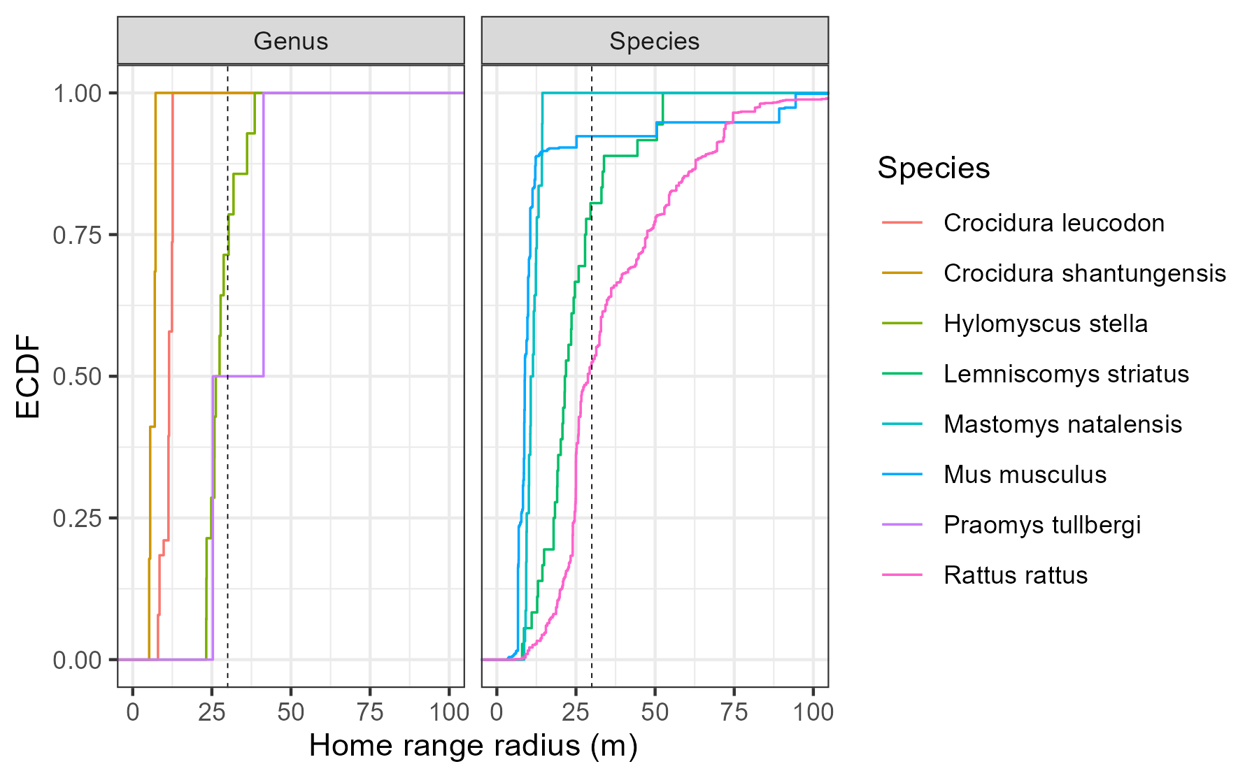

Supplementary Figure 1: Empirical Cumulative Density Function of the home range radius of rodent and shrew species with data available in the HomeRange dataset. Species that match detected genera in our study include two shrew species Crocidura leucodon and Crocidura shantungensis and two rodent species Hylomyscus stella and Praomys tullbergi. Four species matches to rodent species detected in our study were also included Lemniscomys striatus, Mastomys natalensis, Mus musculus and Rattus rattus. Only Lemniscomys striatus and Mastomys natalensis contain data from Africa (Uganda and Tanzania respectively). The dashed line represents the 30m range radius used for the primary analysis in the current study.

## Supplementary Figure 2

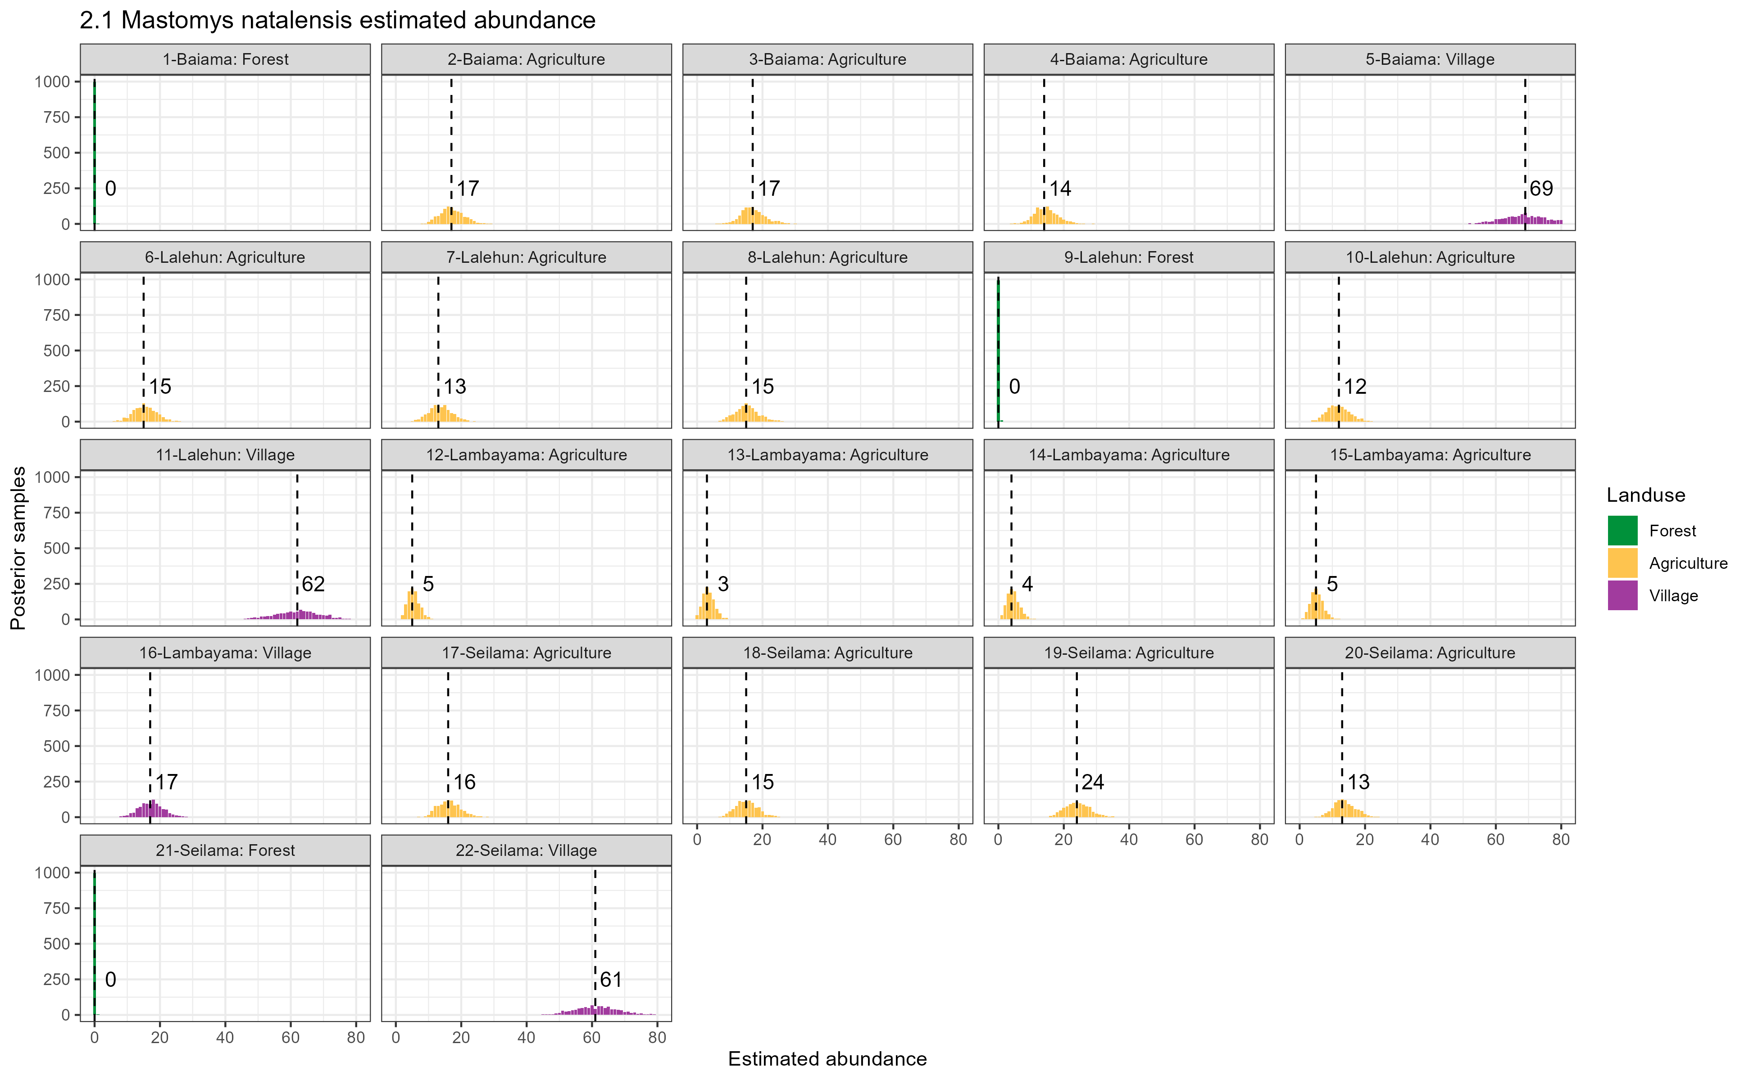

Supplementary Figure 2.1: Estimated abundance at each sampling site for Mastomys natalensis. The dashed line and number is the median abundance used to infer the population size at this study site.

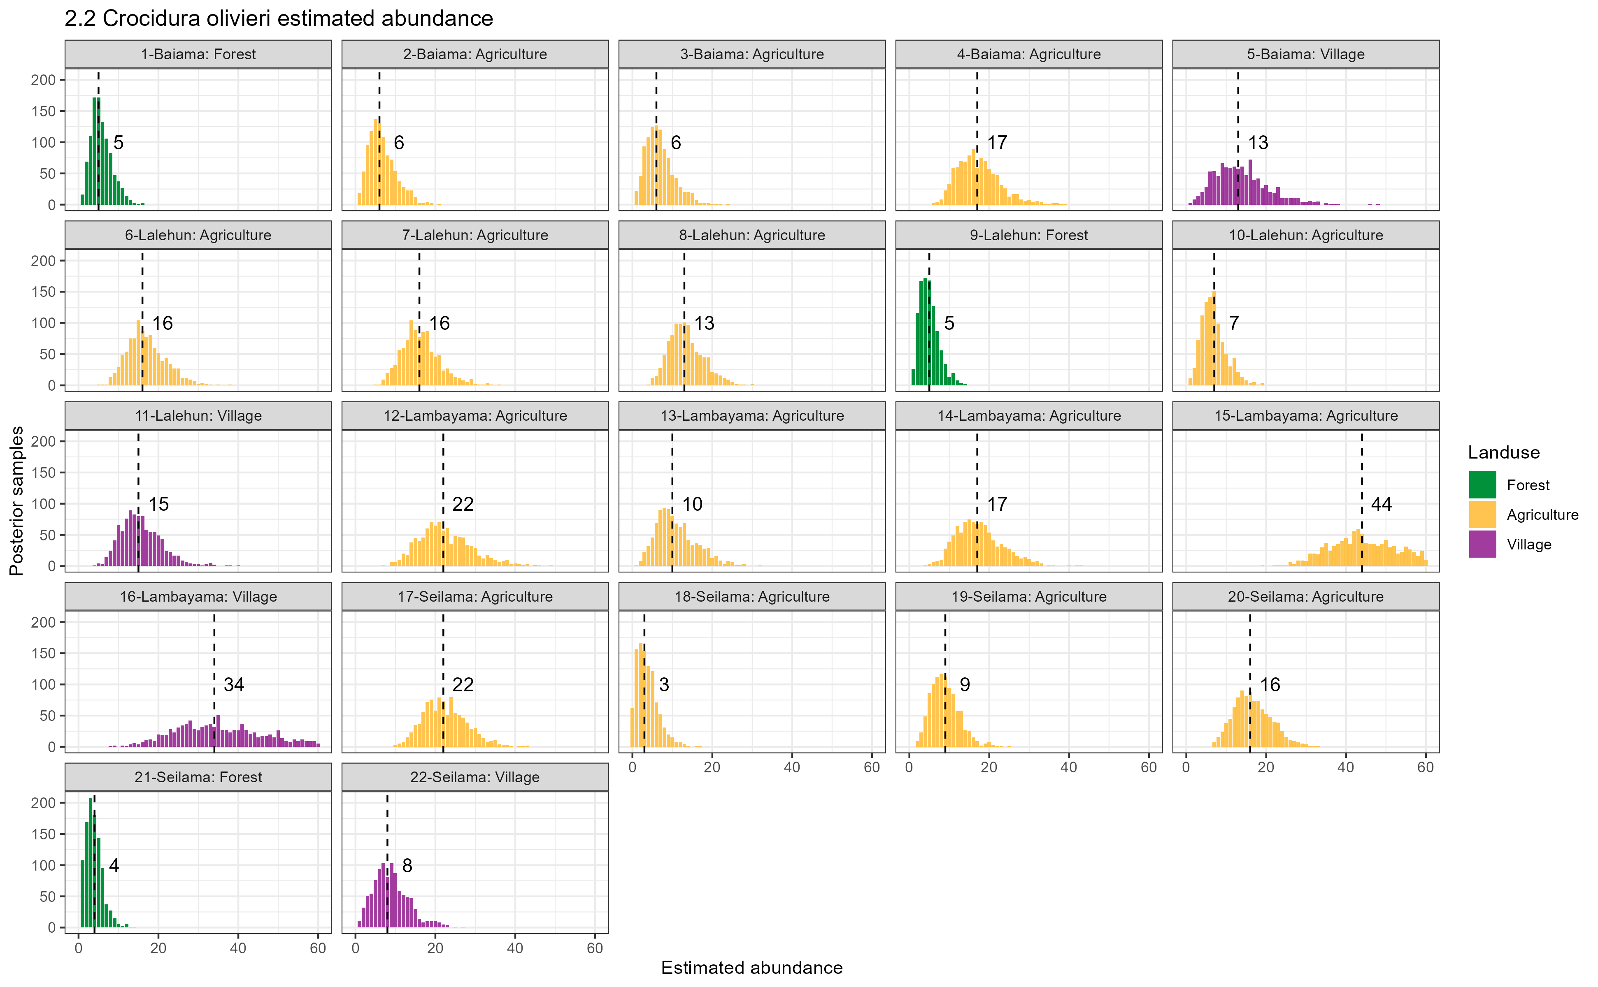

Supplementary Figure 2.2: Estimated abundance at each sampling site for Crocidura olivieri. The dashed line and number is the median abundance used to infer the population size at this study site.

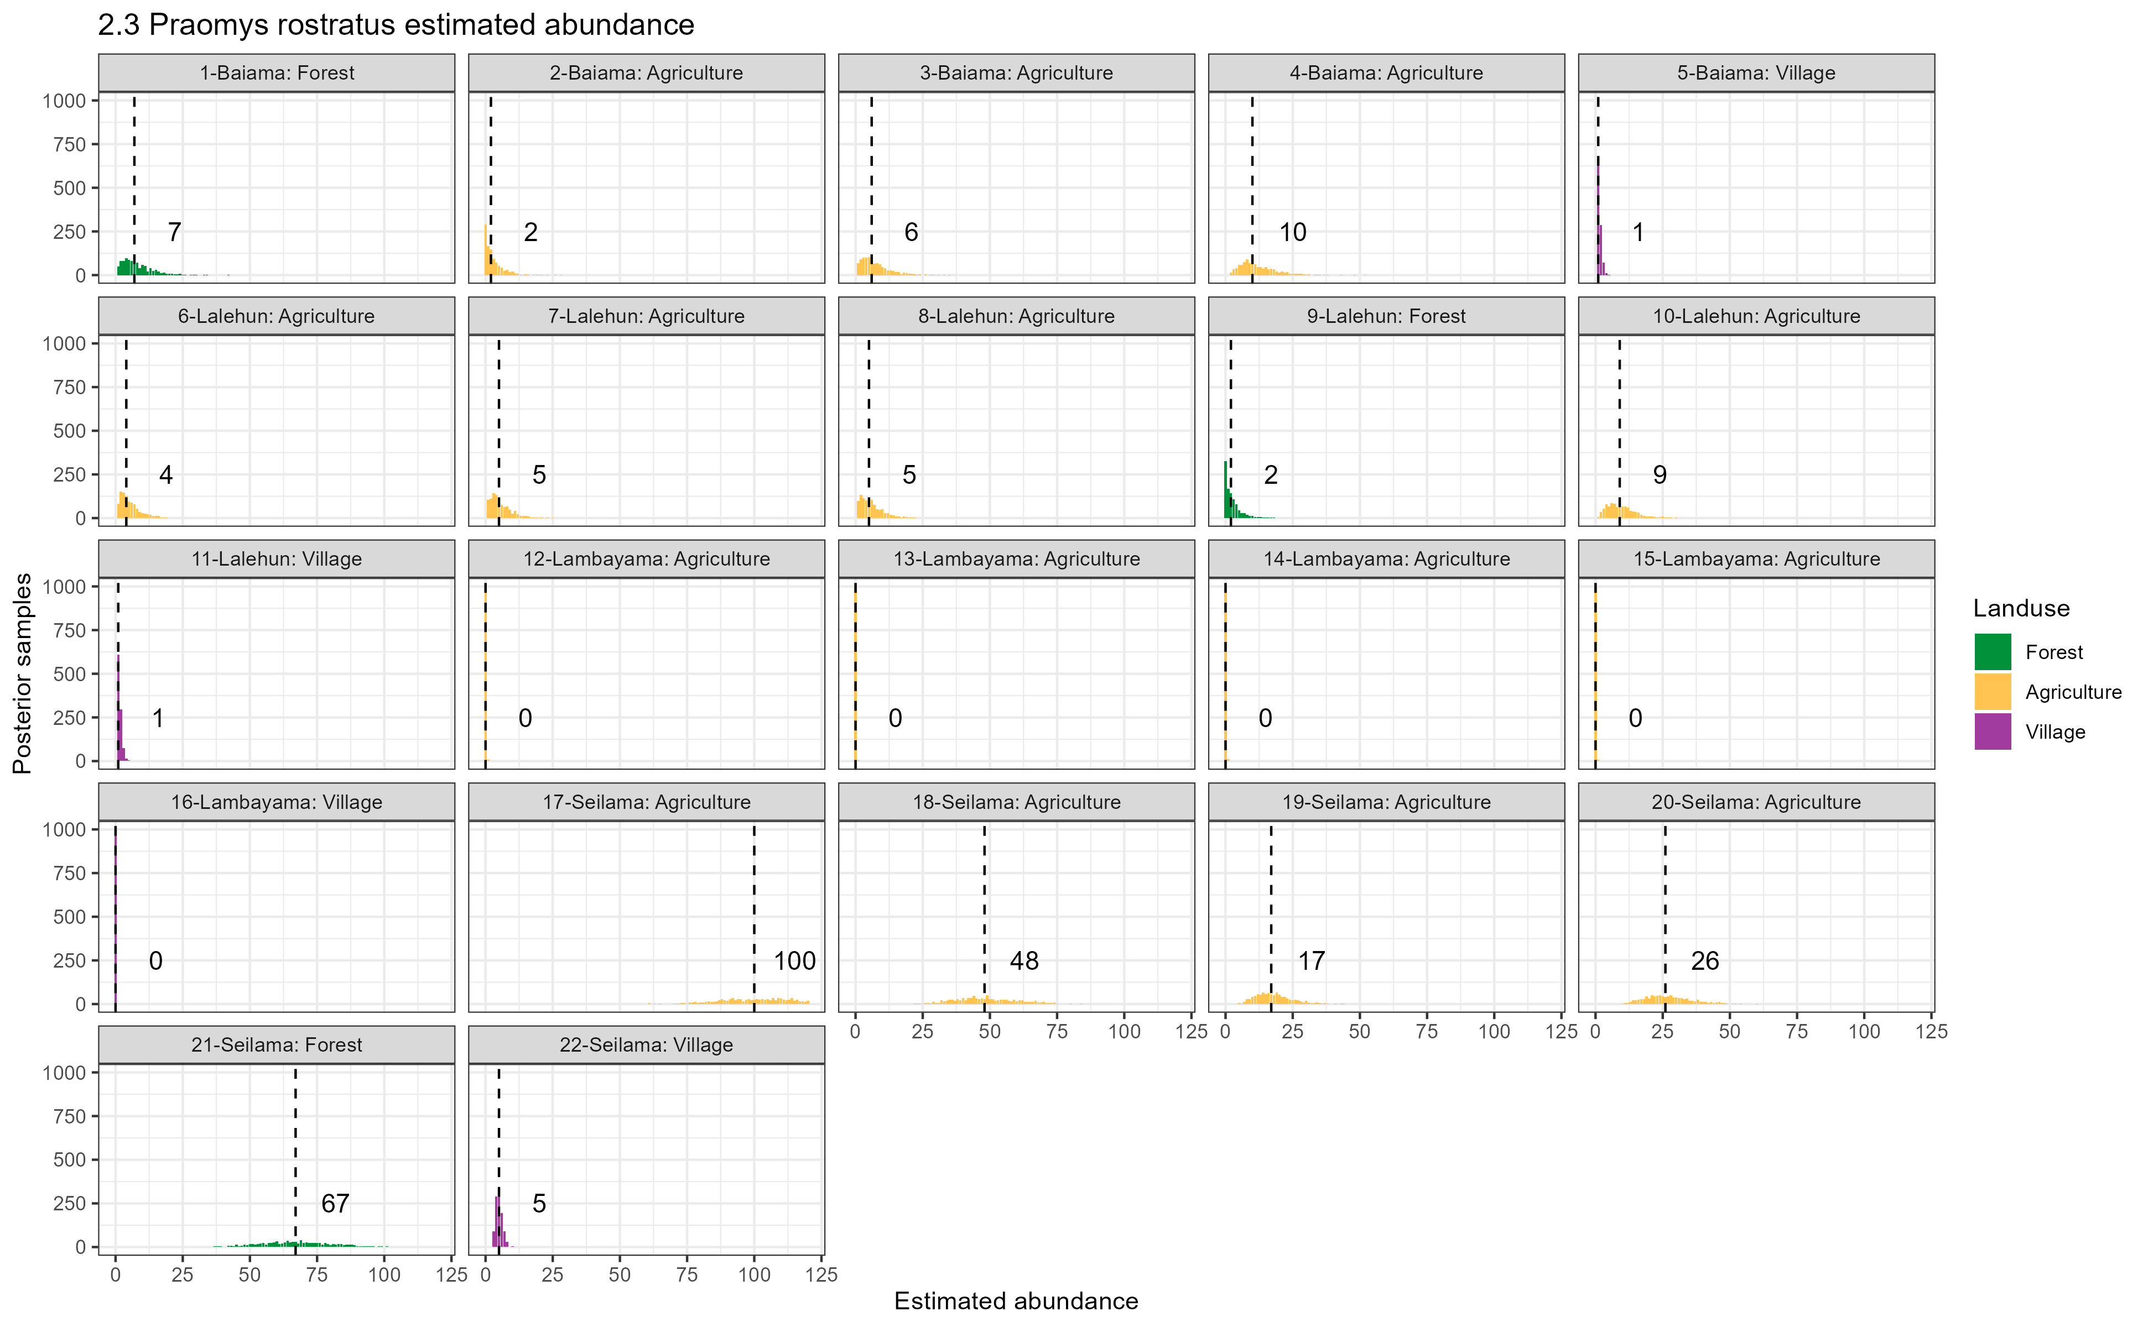

Supplementary Figure 2,3: Estimated abundance at each sampling site for Praomys rostratus. The dashed line and number is the median abundance used to infer the population size at this study site.

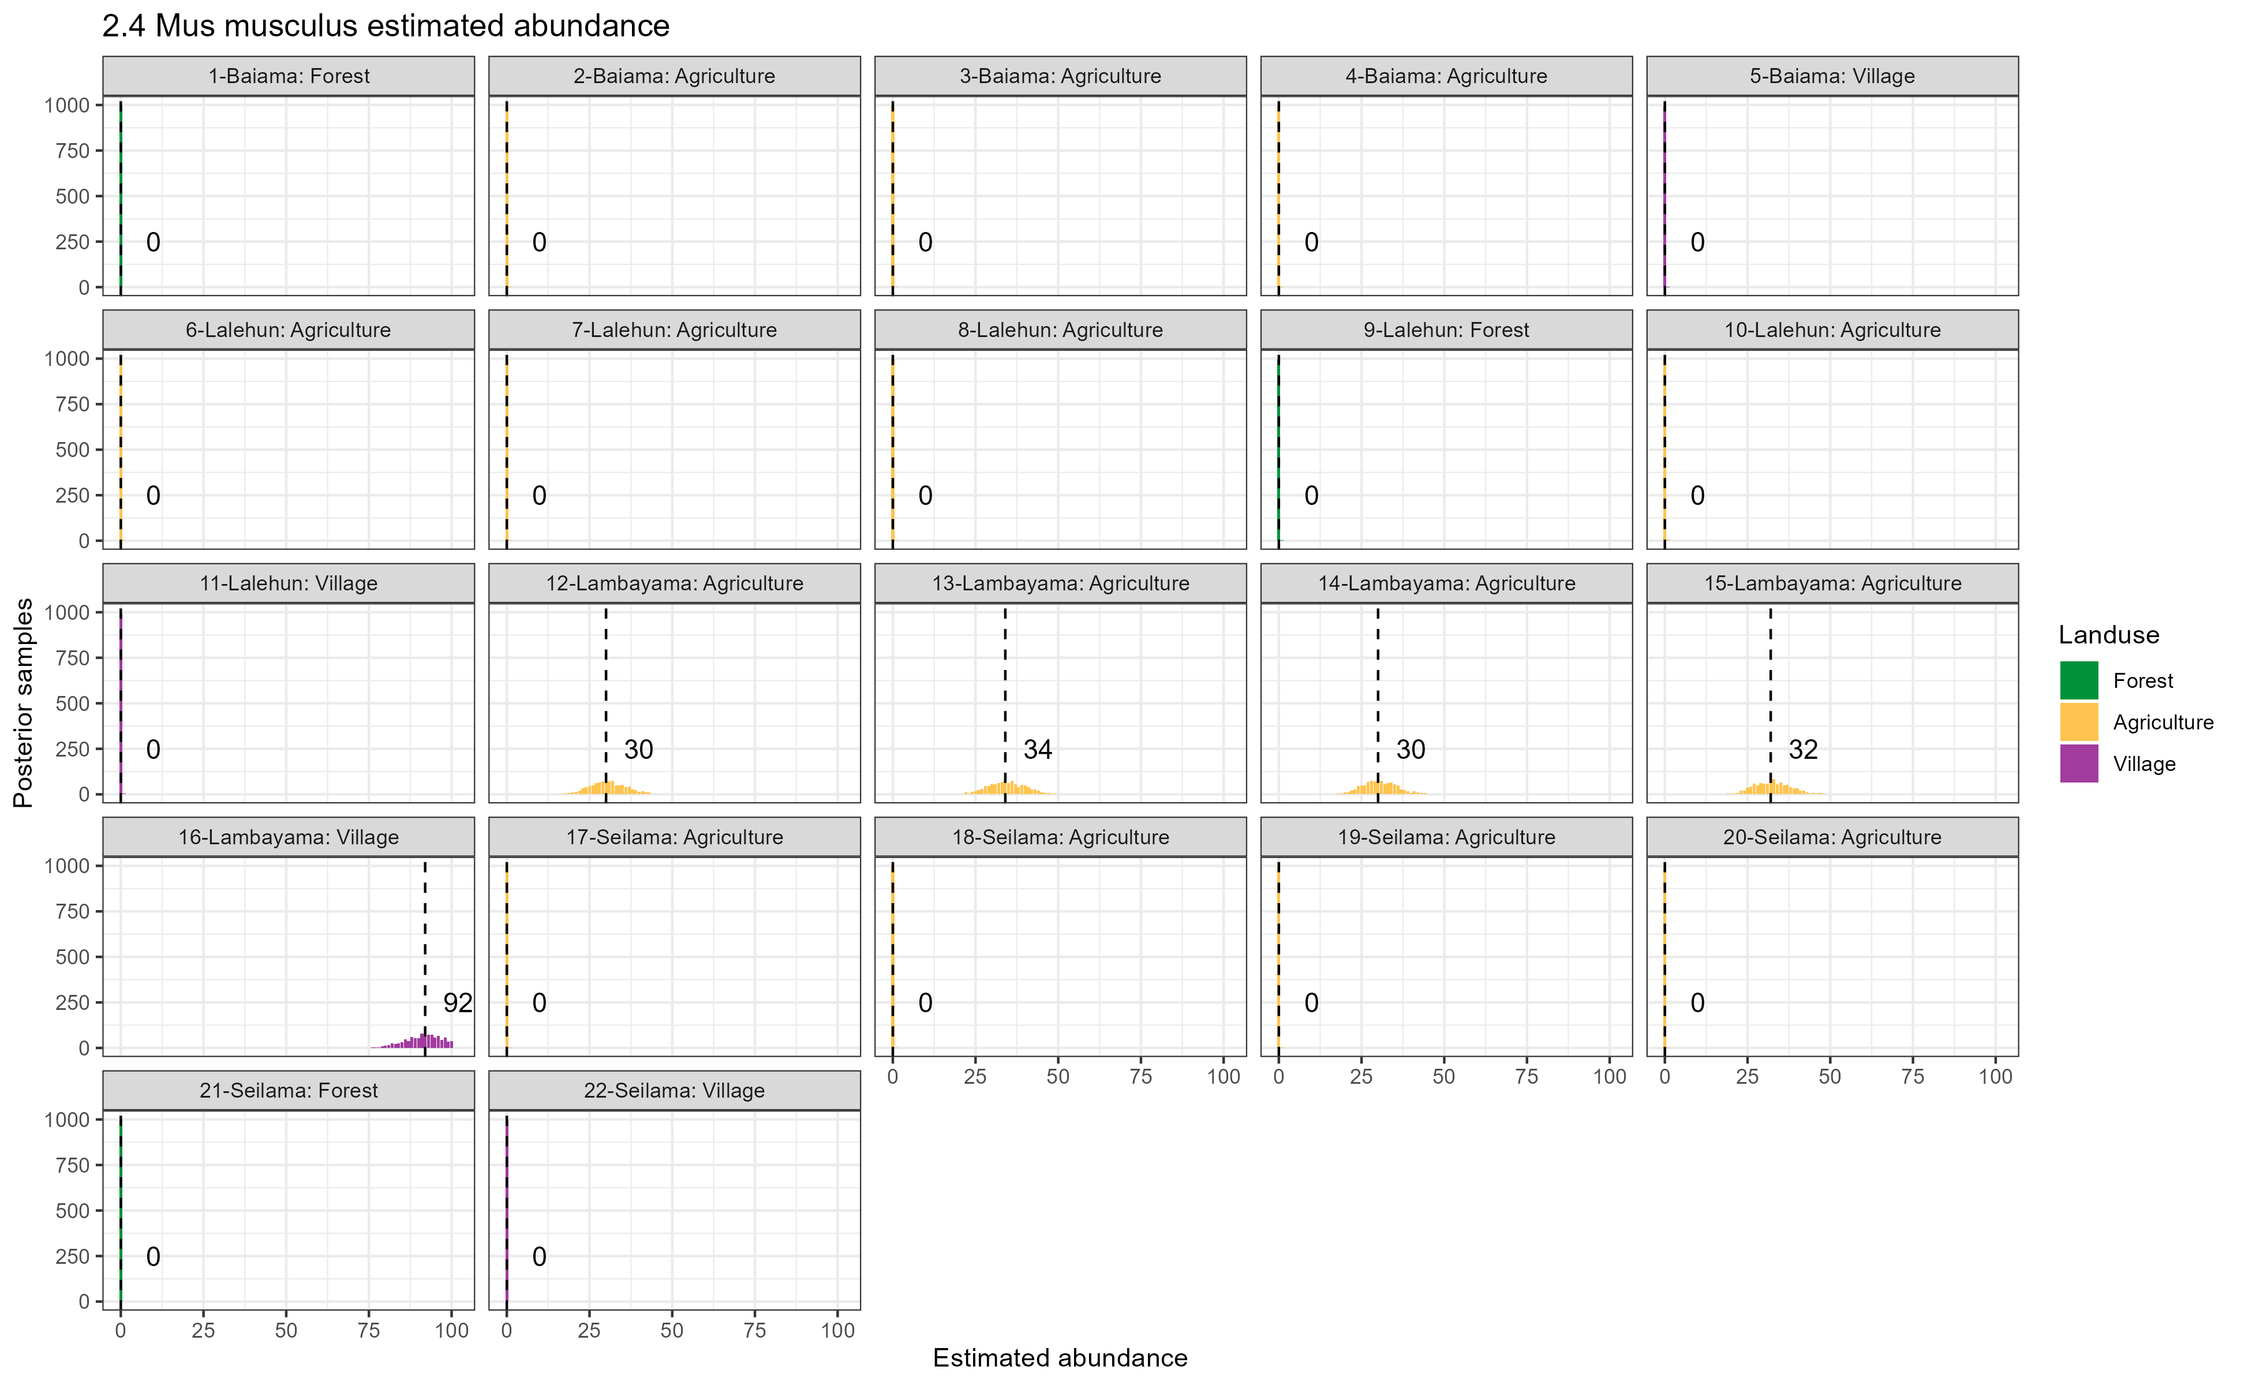

Supplementary Figure 2.4: Estimated abundance at each sampling site for Mus musculus. The dashed line and number is the median abundance used to infer the population size at this study site.

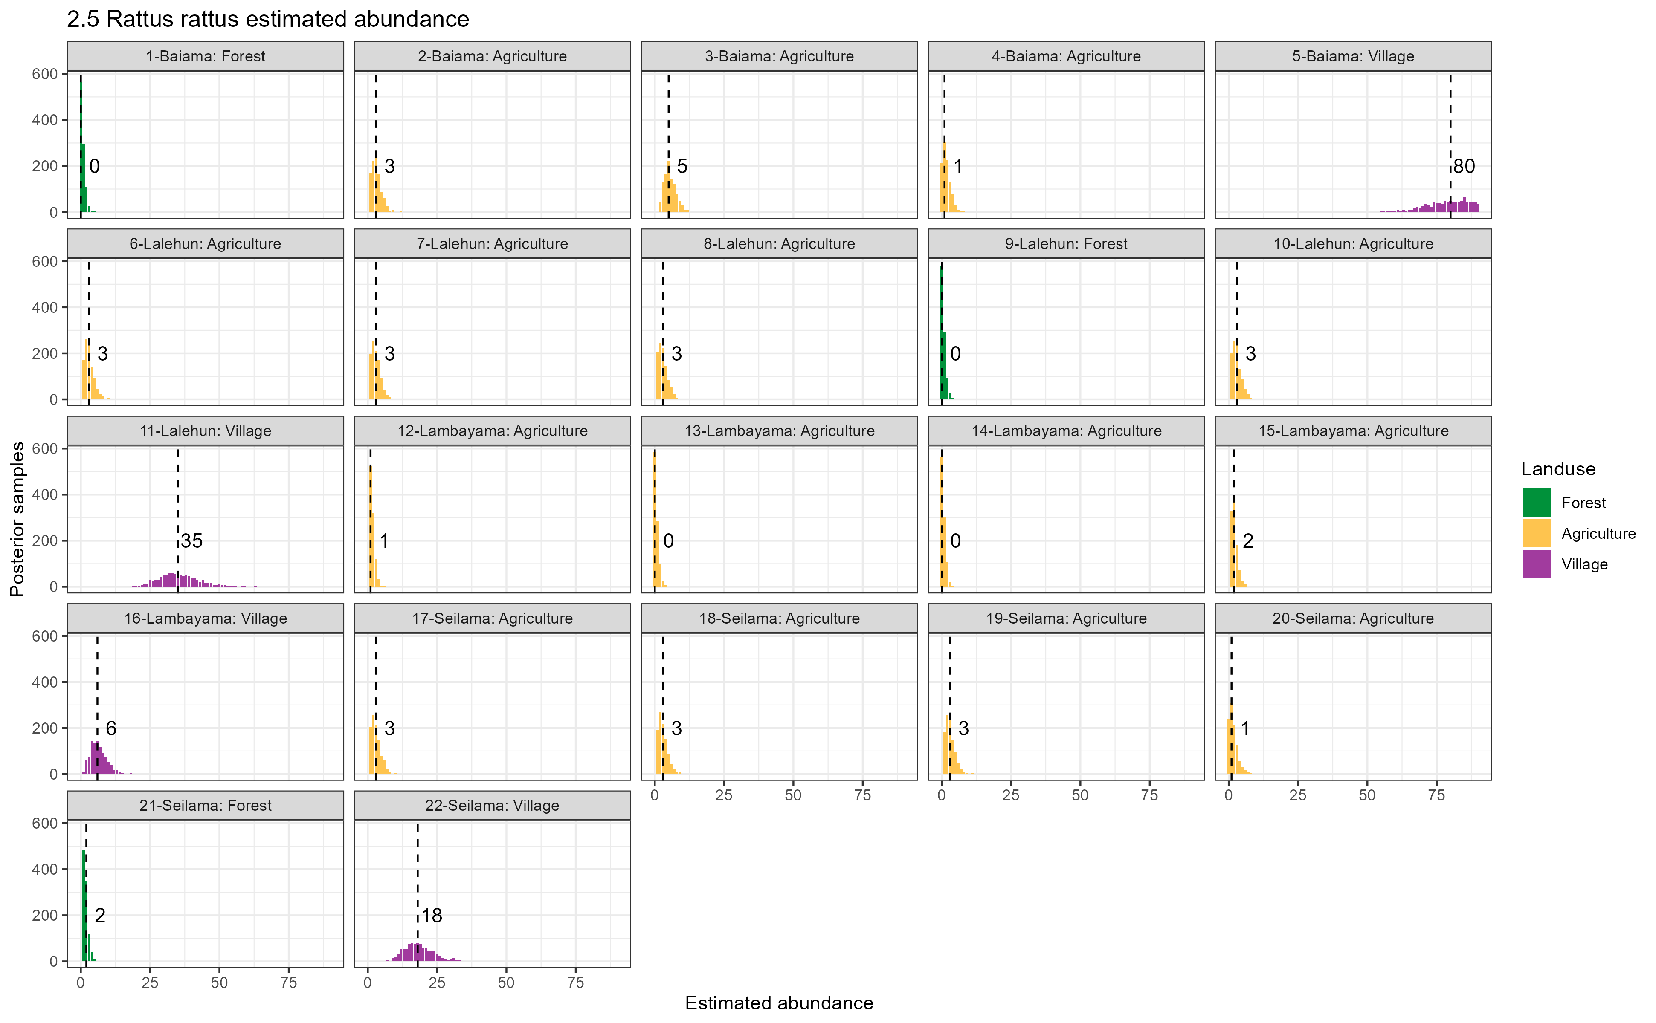

Supplementary Figure 2.5: Estimated abundance at each sampling site for Rattus rattus. The dashed line and number is the median abundance used to infer the population size at this study site.

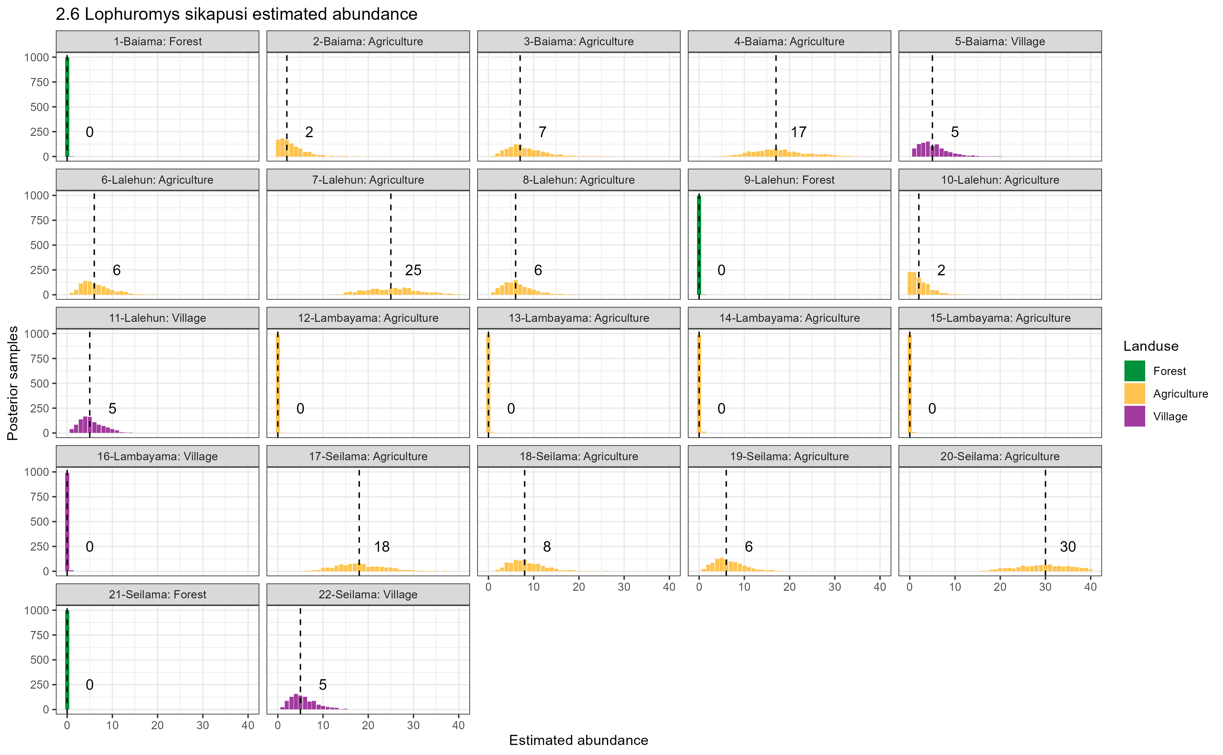

Supplementary Figure 2.6: Estimated abundance at each sampling site for Lophuromys sikapusi. The dashed line and number is the median abundance used to infer the population size at this study site.

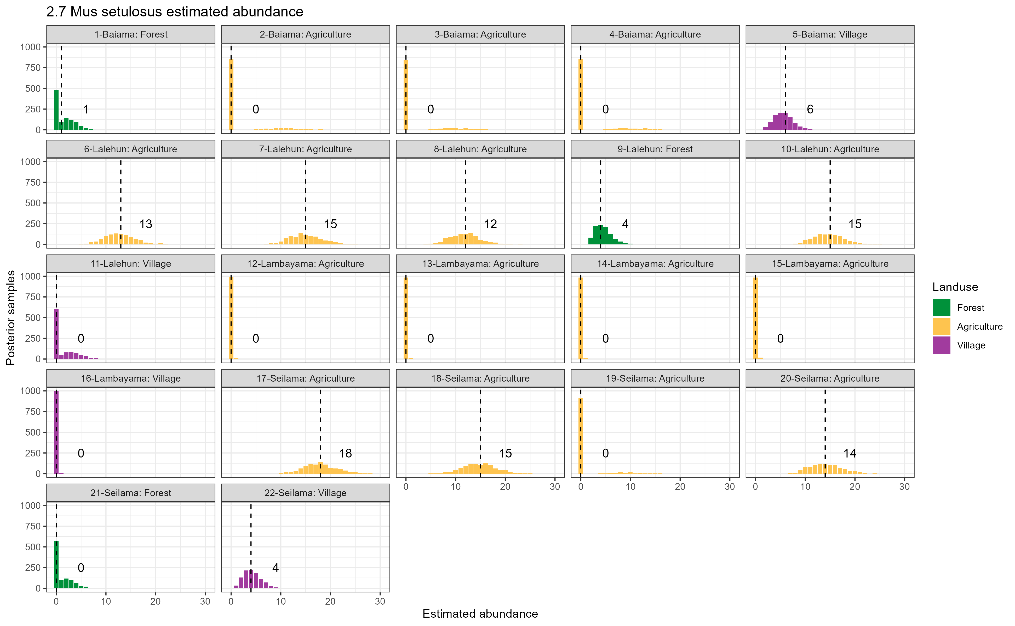

Supplementary Figure 2.7: Estimated abundance at each sampling site for Mus setulosus. The dashed line and number is the median abundance used to infer the population size at this study site.

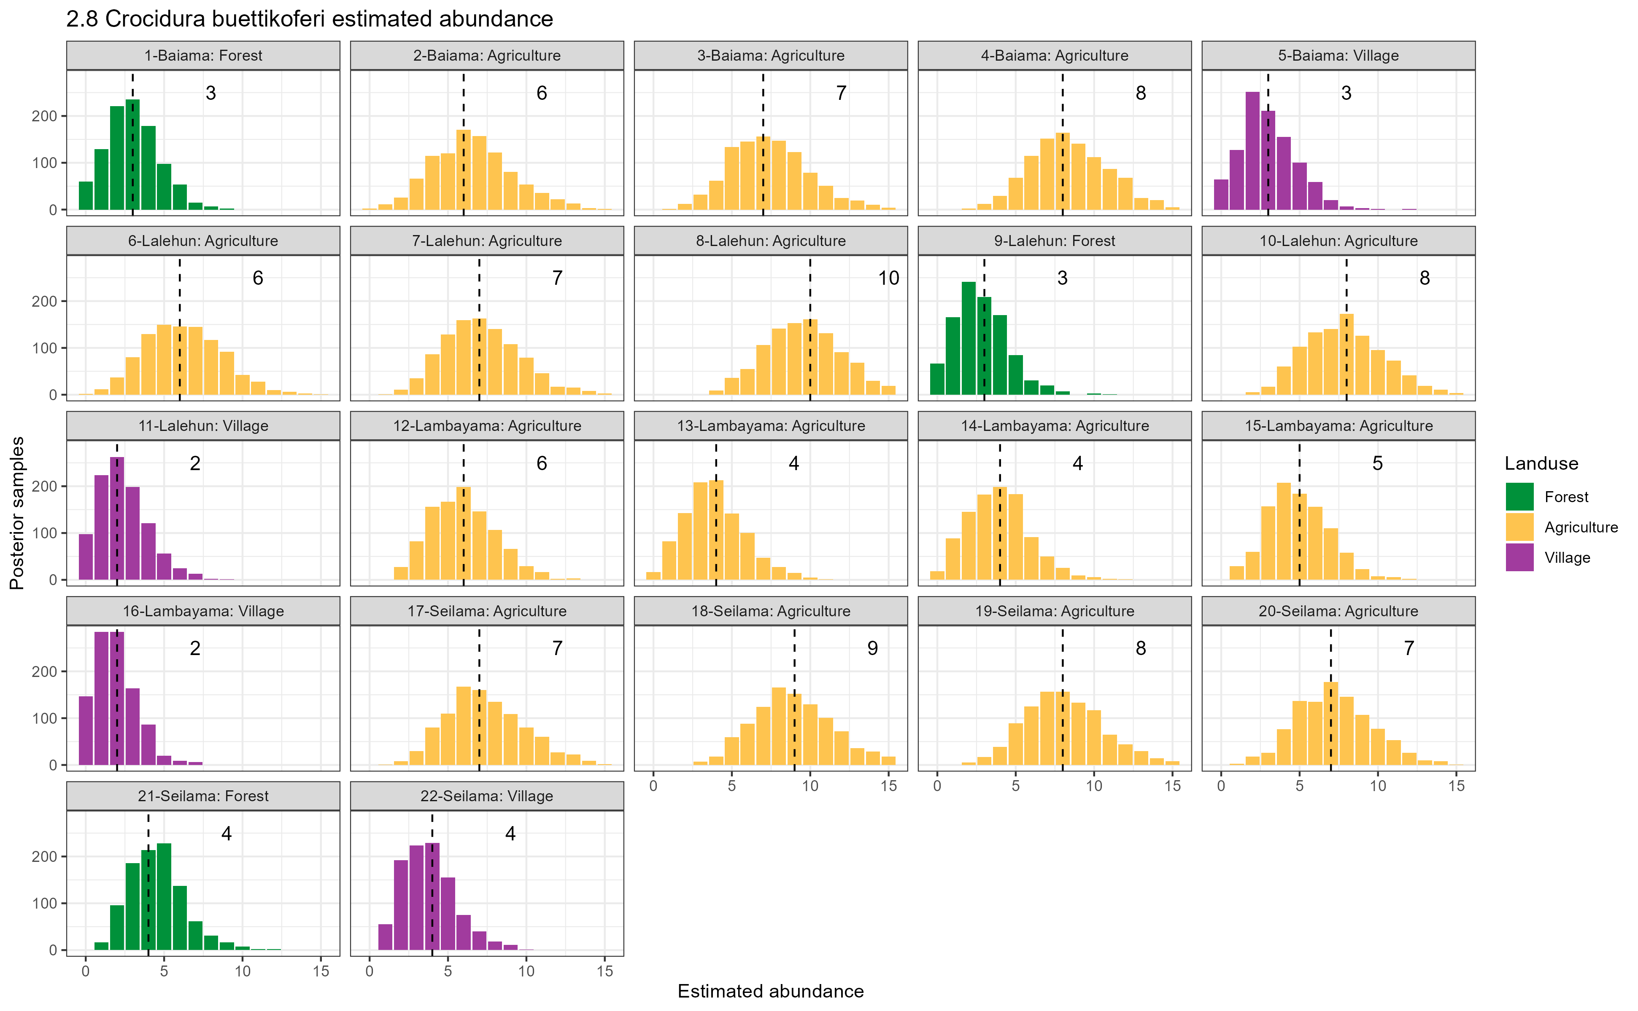

Supplementary Figure 2.8: Estimated abundance at each sampling site for Crocidura buettikoferi. The dashed line and number is the median abundance used to infer the population size at this study site.

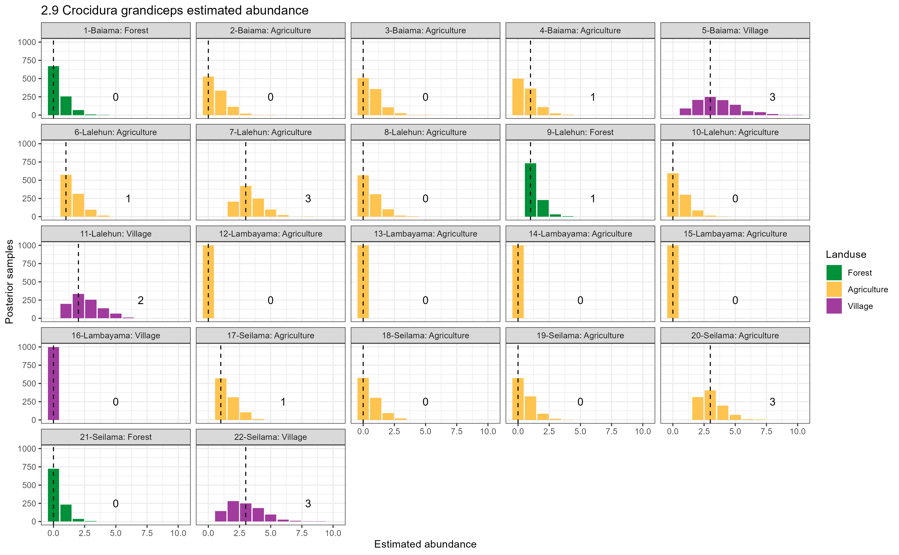

Supplementary Figure 2.9: Estimated abundance at each sampling site for Crocidura grandiceps. The dashed line and number is the median abundance used to infer the population size at this study site.

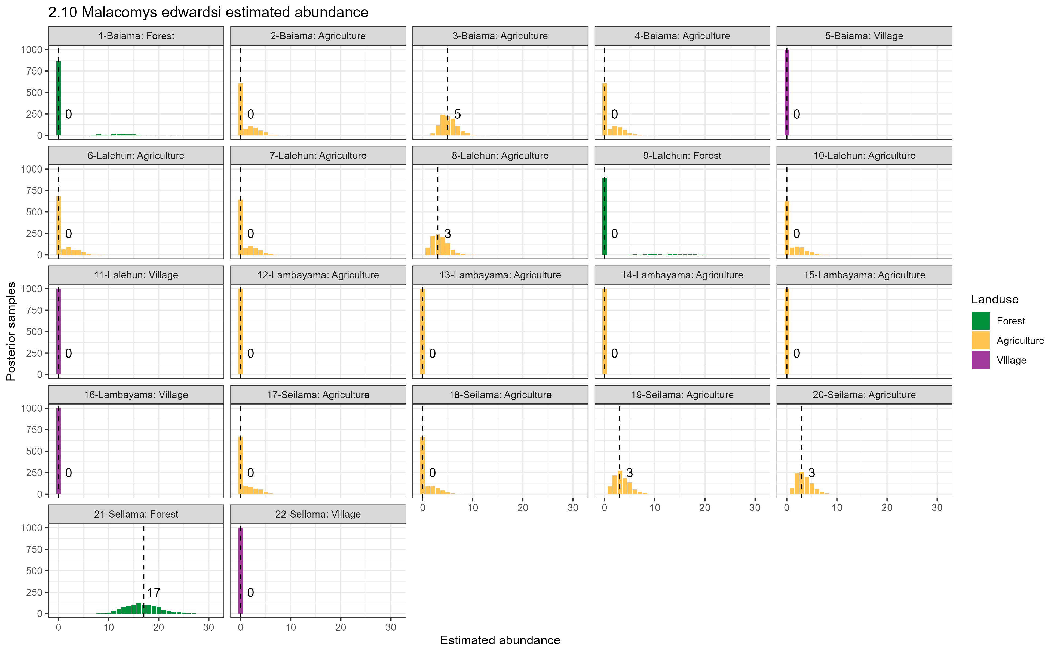

Supplementary Figure 2.10: Estimated abundance at each sampling site for Malacomys edwardsi. The dashed line and number is the median abundance used to infer the population size at this study site.

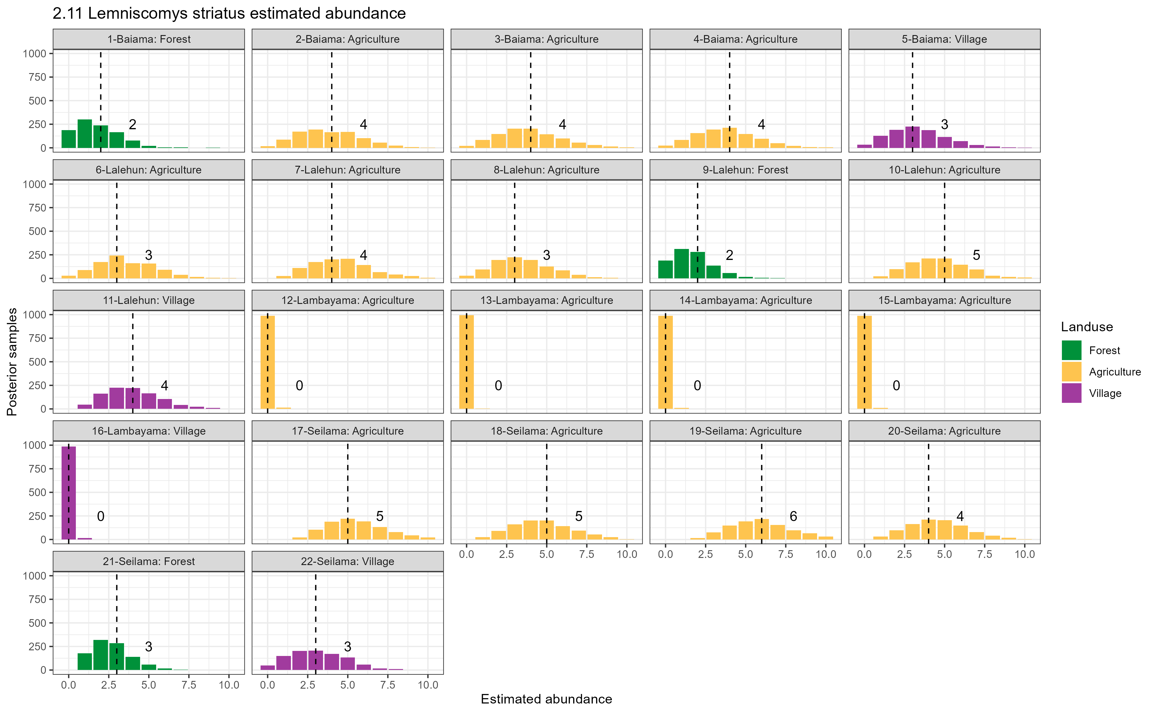

Supplementary Figure 2.11: Estimated abundance at each sampling site for Lemniscomys striatus. The dashed line and number is the median abundance used to infer the population size at this study site.

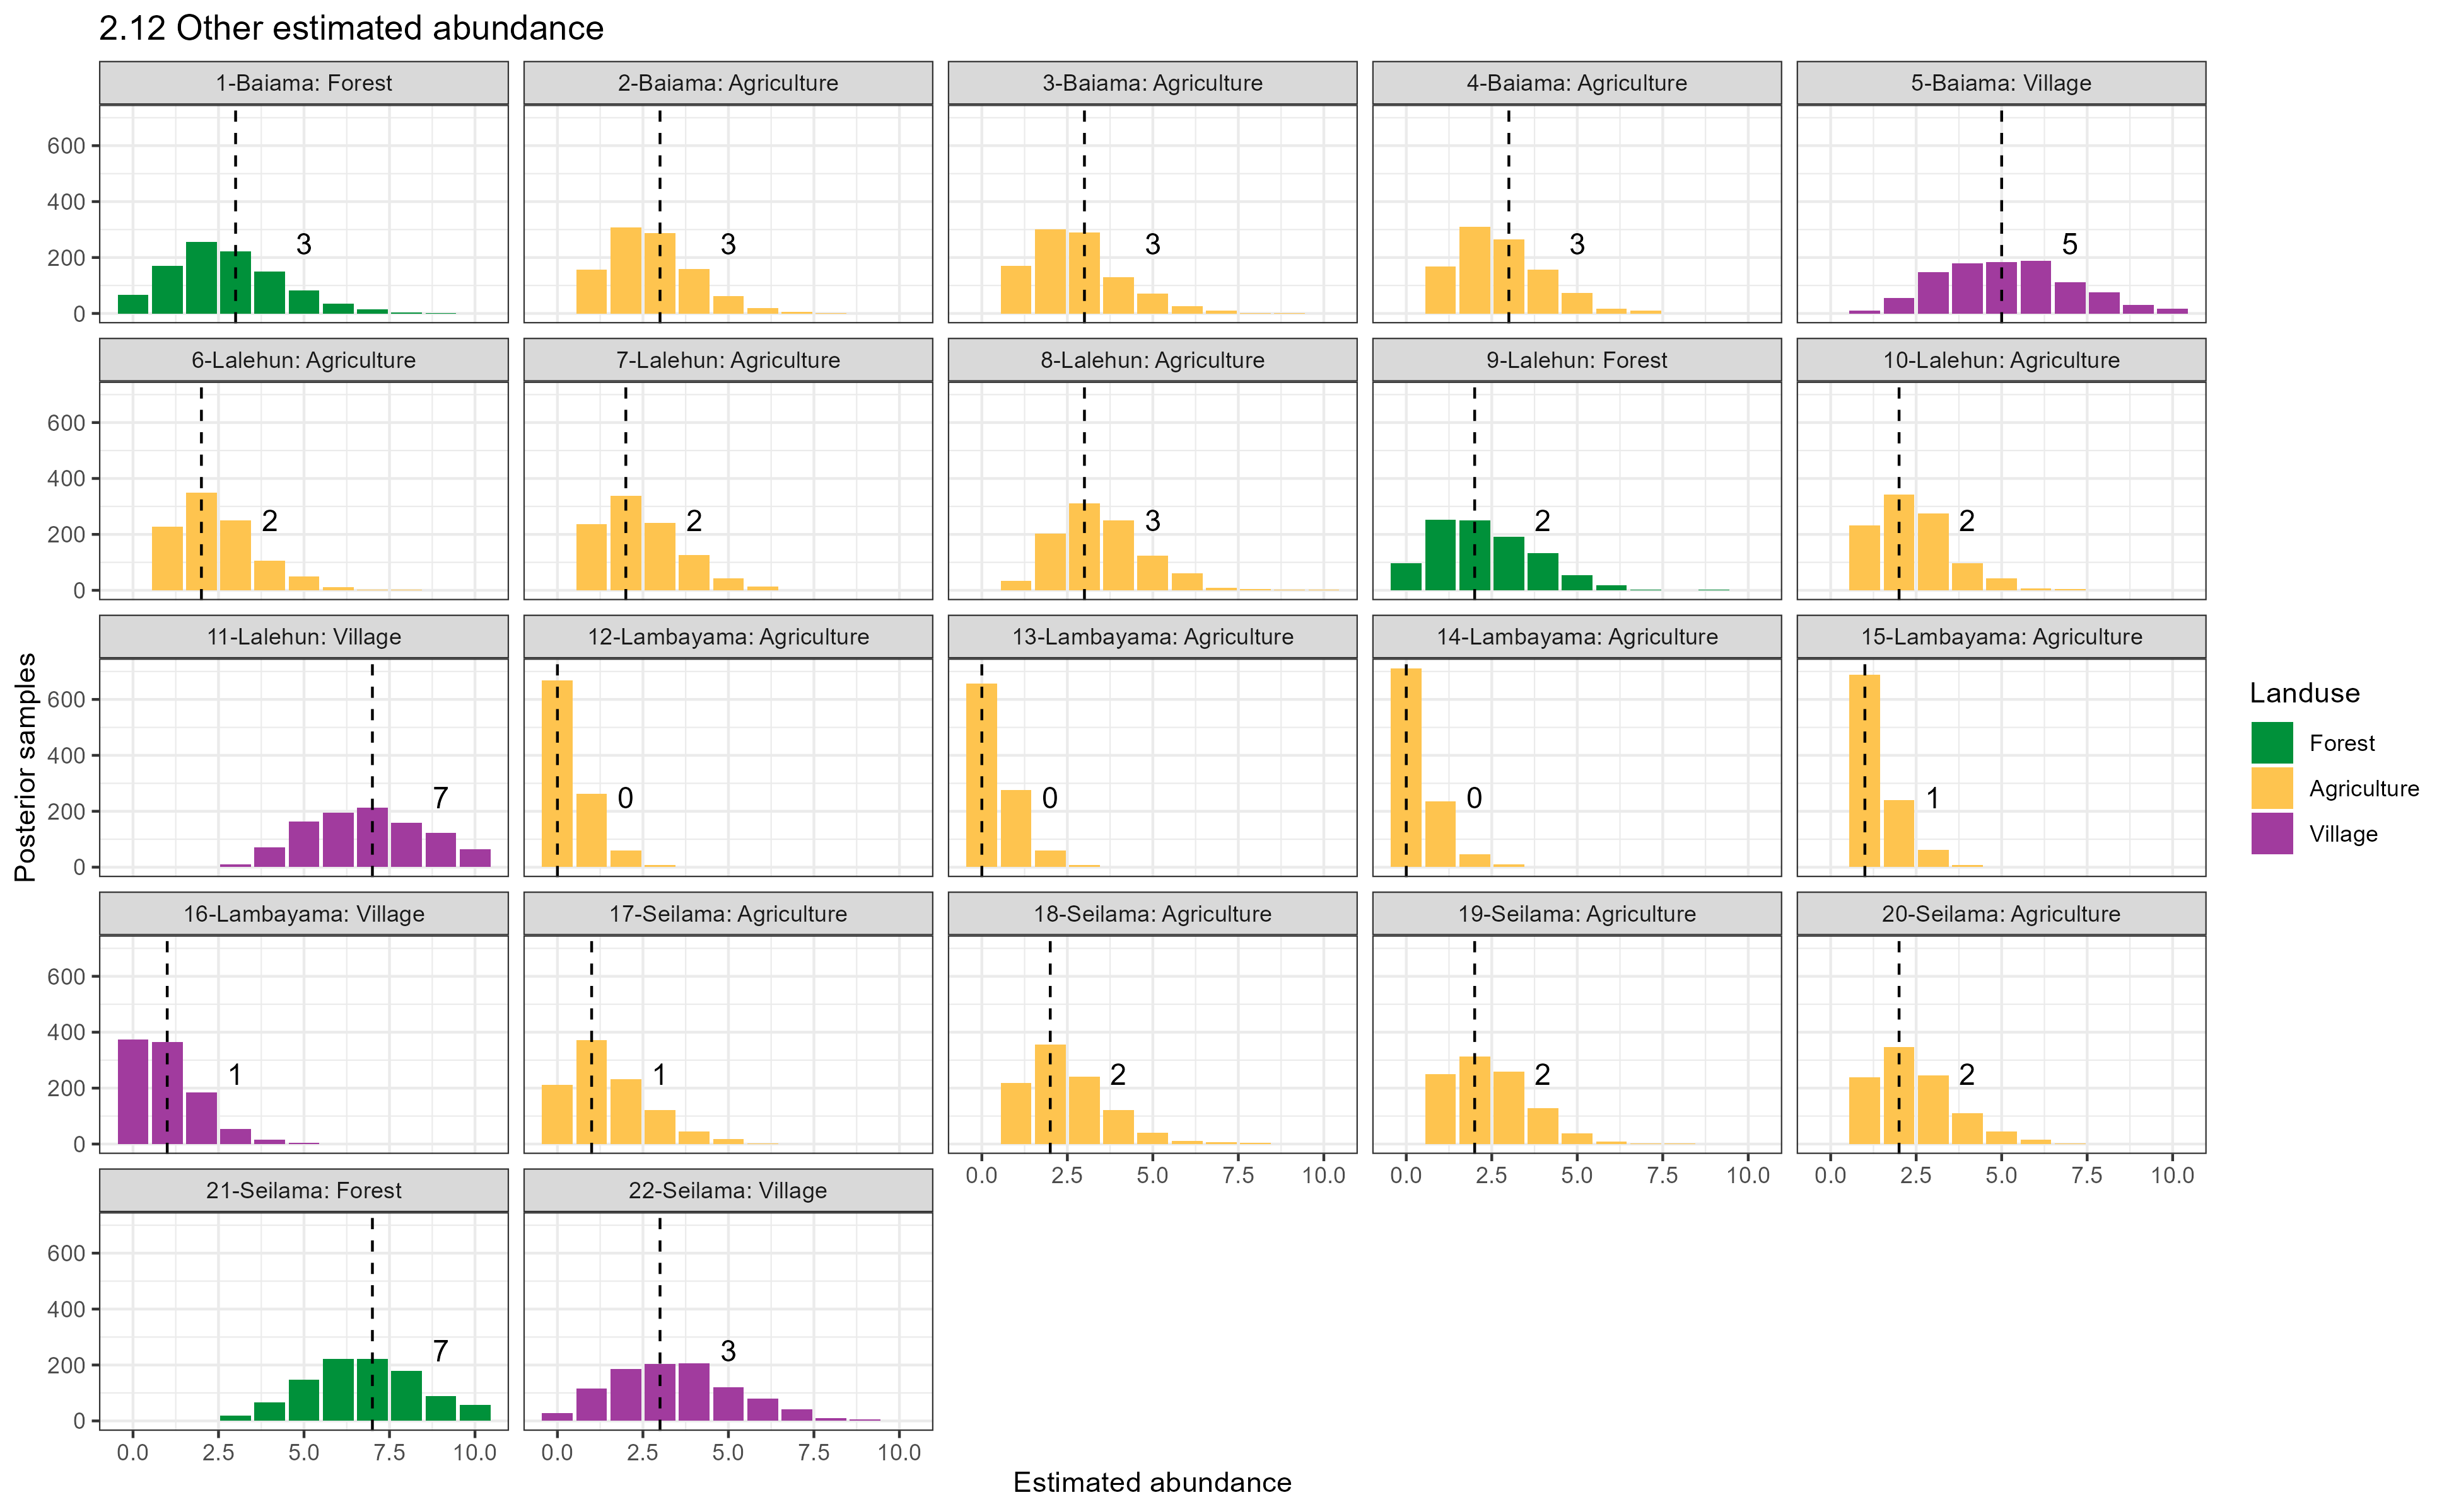

Supplementary Figure 2.12: Estimated abundance at each sampling site for Other species. The dashed line and number is the median abundance used to infer the population size at this study site.

## Supplementary Figure 3

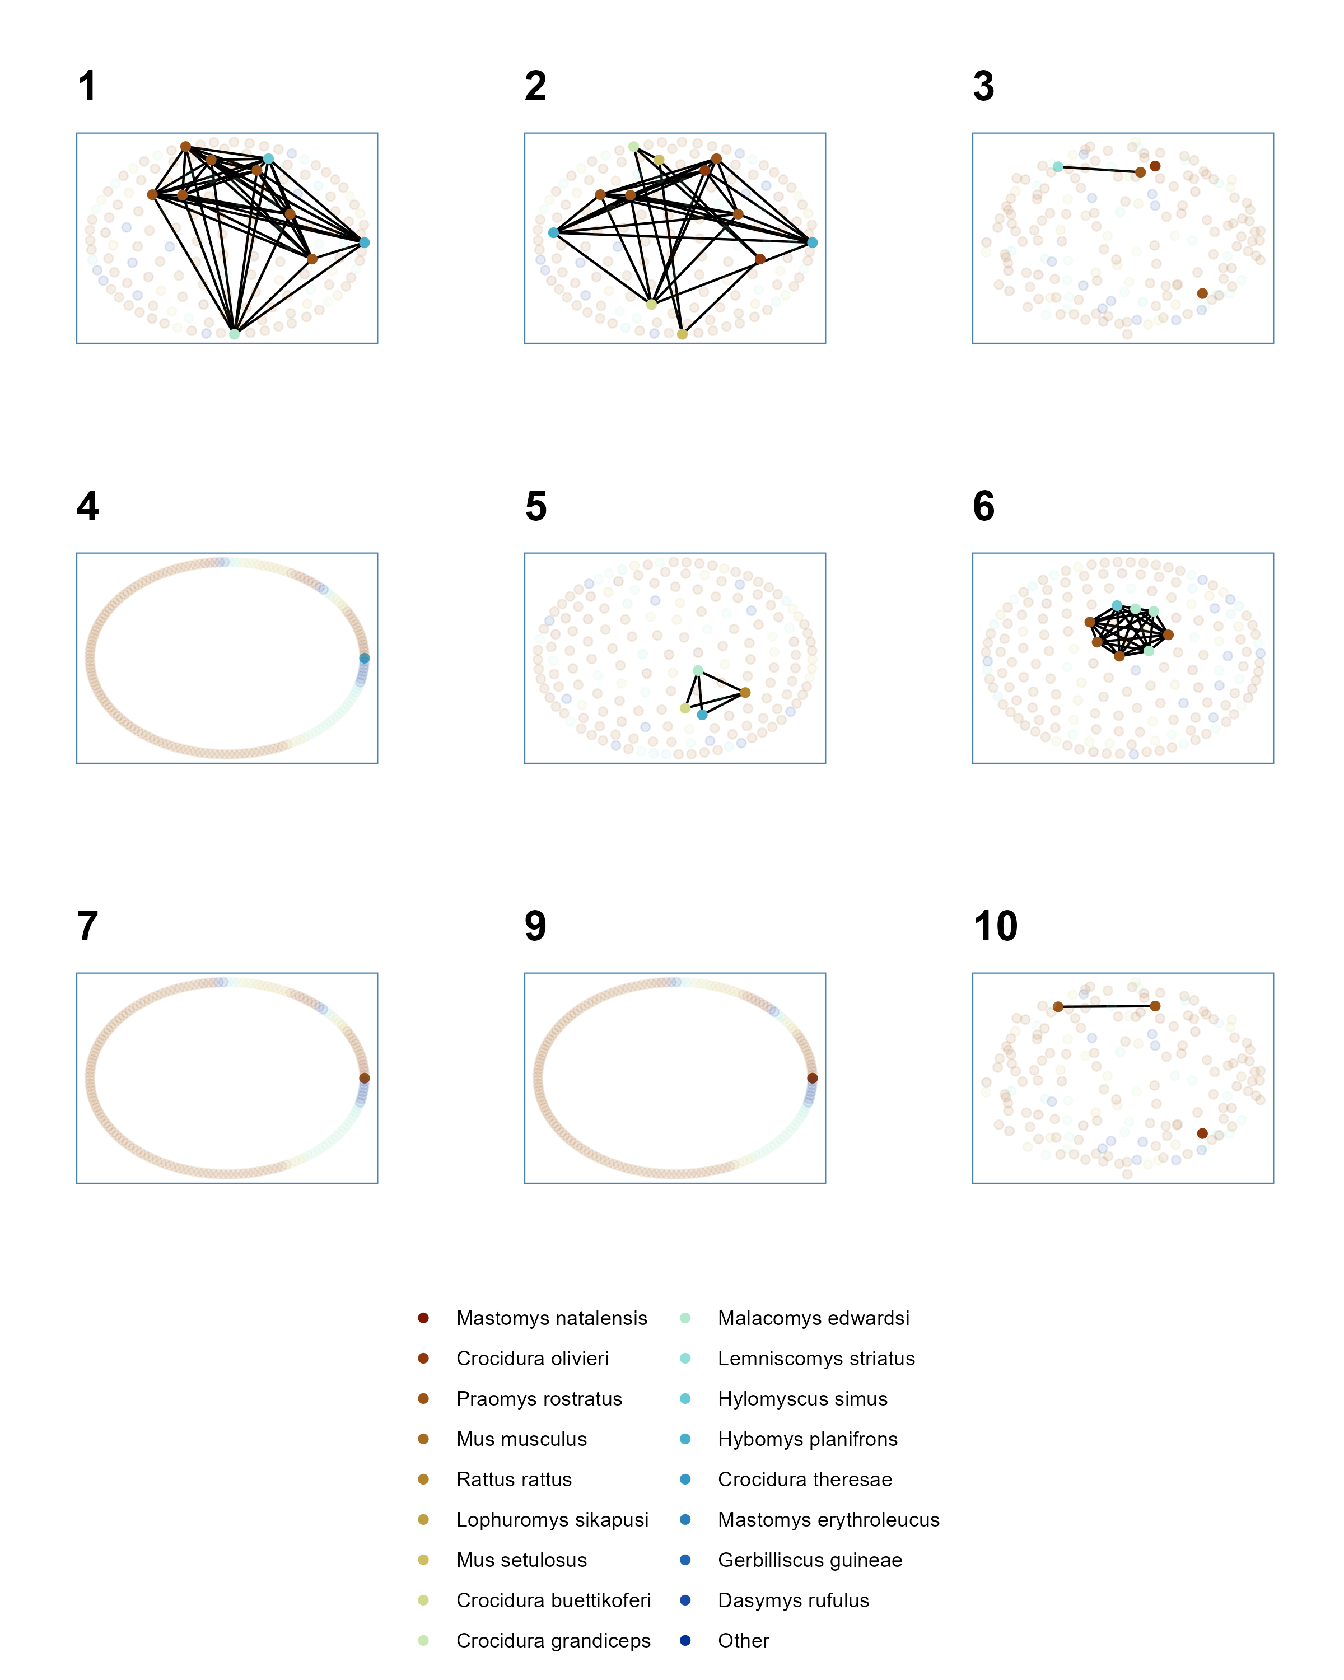

Supplementary Figure 3.1: Networks produced from trapping sessions conducted in forest settings. Numbers refer to the trapping session, no individuals were detected in forest during trapping session 8. Observed individuals are shown in solid colours with colour referring to species. Unobserved individuals estimated from abundance modelling are shown in pale colours. Contacts between individuals (edges) are shown for observed individuals only.

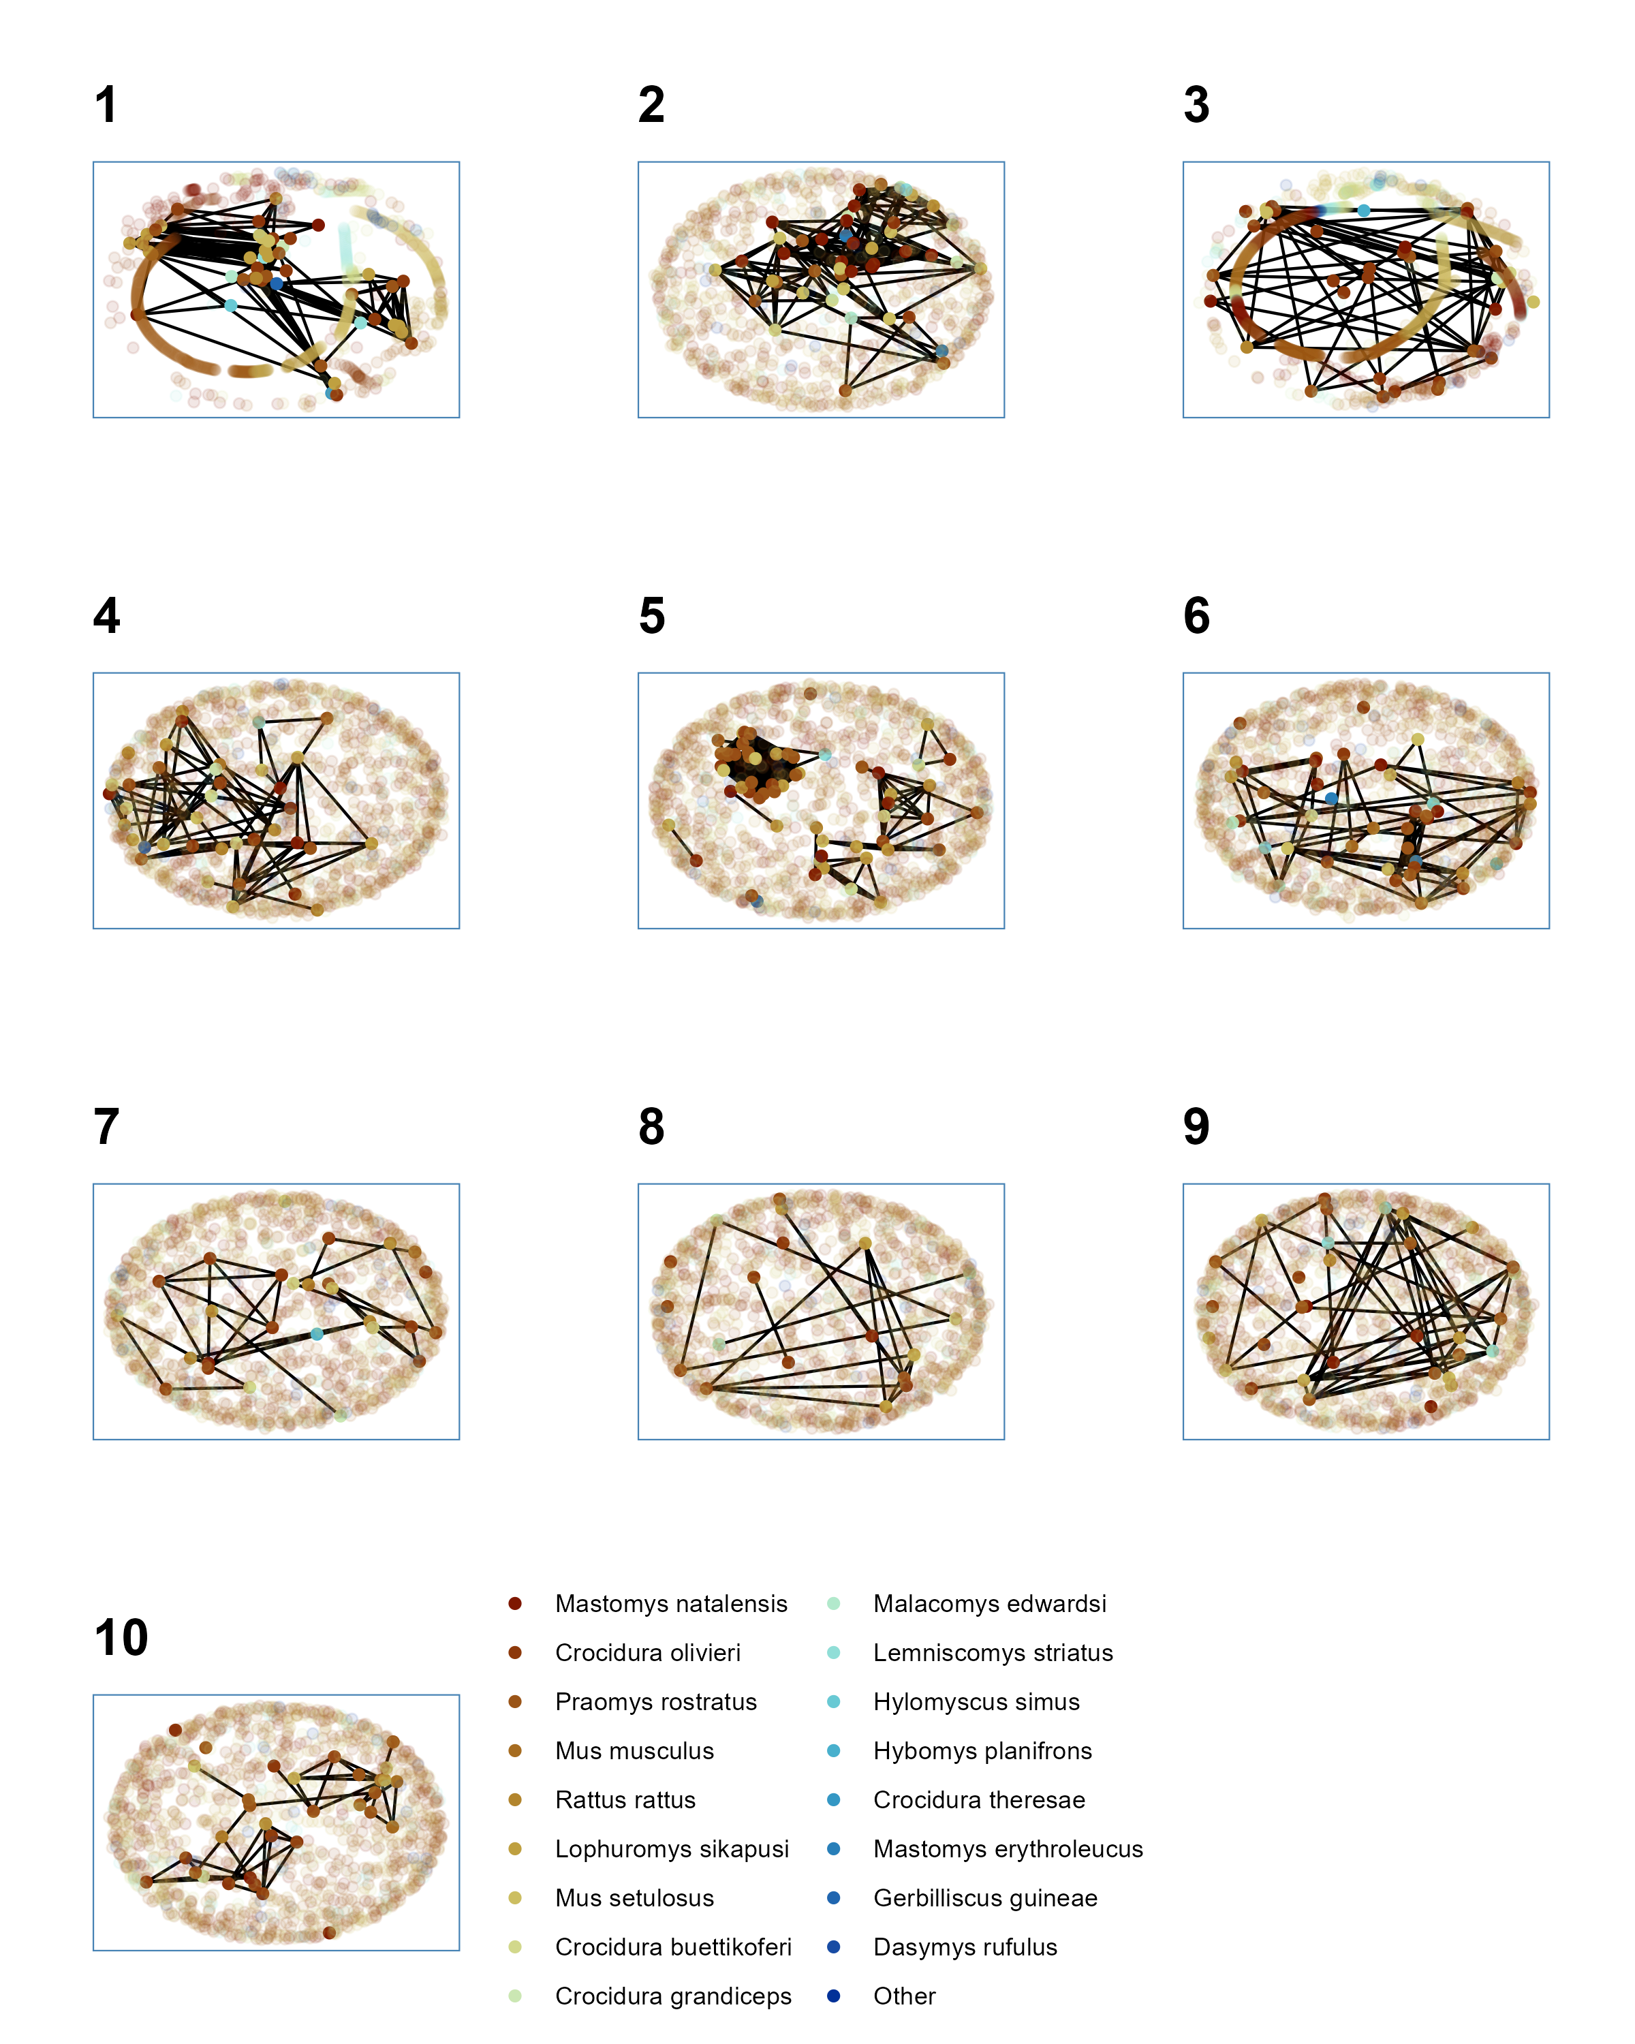

Supplementary Figure 3.2: Networks produced from trapping sessions conducted in agricultural settings. Numbers refer to the trapping session. Observed individuals are shown in solid colours with colour referring to species. Unobserved individuals estimated from abundance modelling are shown in pale colours. Contacts between individuals (edges) are shown for observed individuals only.

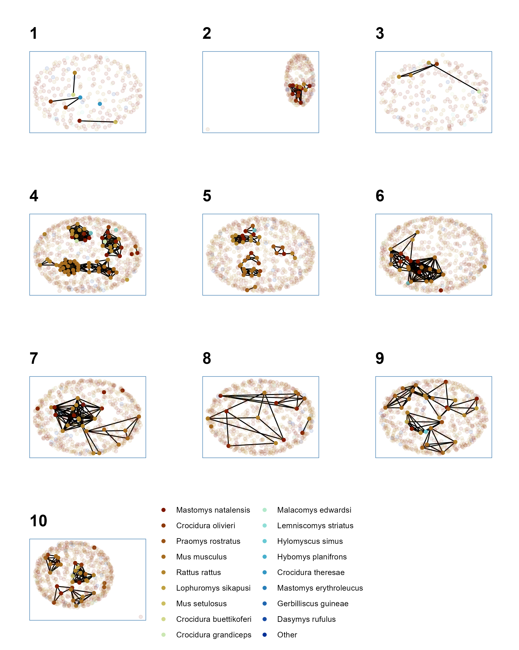

Supplementary Figure 3.3: Networks produced from trapping sessions conducted in village settings. Numbers refer to the trapping session. Observed individuals are shown in solid colours with colour referring to species. Unobserved individuals estimated from abundance modelling are shown in pale colours. Contacts between individuals (edges) are shown for observed individuals only.

## Supplementary Figure 4

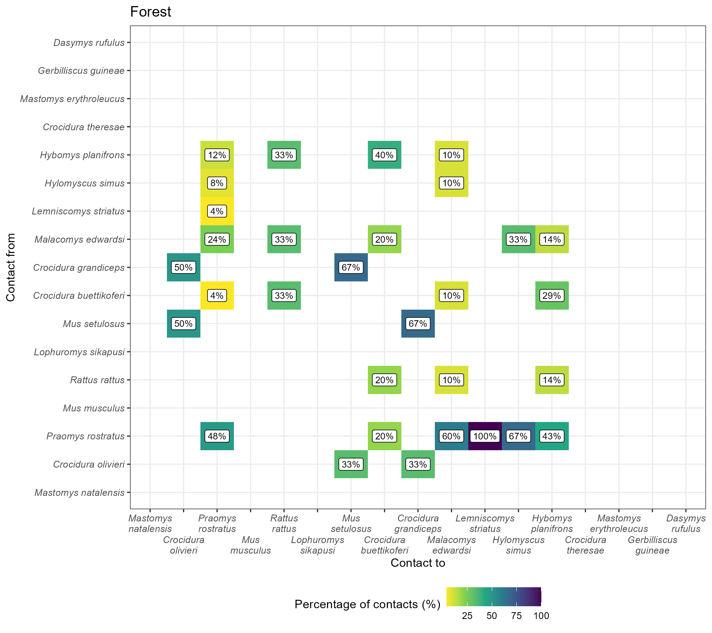

Supplementary Figure 4.1: The proportion of contacts between individual small mammals in forest land use. Darker colours indicate increasing proportions of observed contacts to a species (Contact to) from named species (Contact from). Numbers in the cells correspond to the proportion of contacts to a species from a named species. For example, 56% of all contacts to Praomys rostratus are from other P. rostratus while 16% of contacts are from Malacomys edwardsi. Percentages sum to 100% in the Contact to axis, while they may exceed 100% in Contact from. Species are ordered by the total number detected in this study.

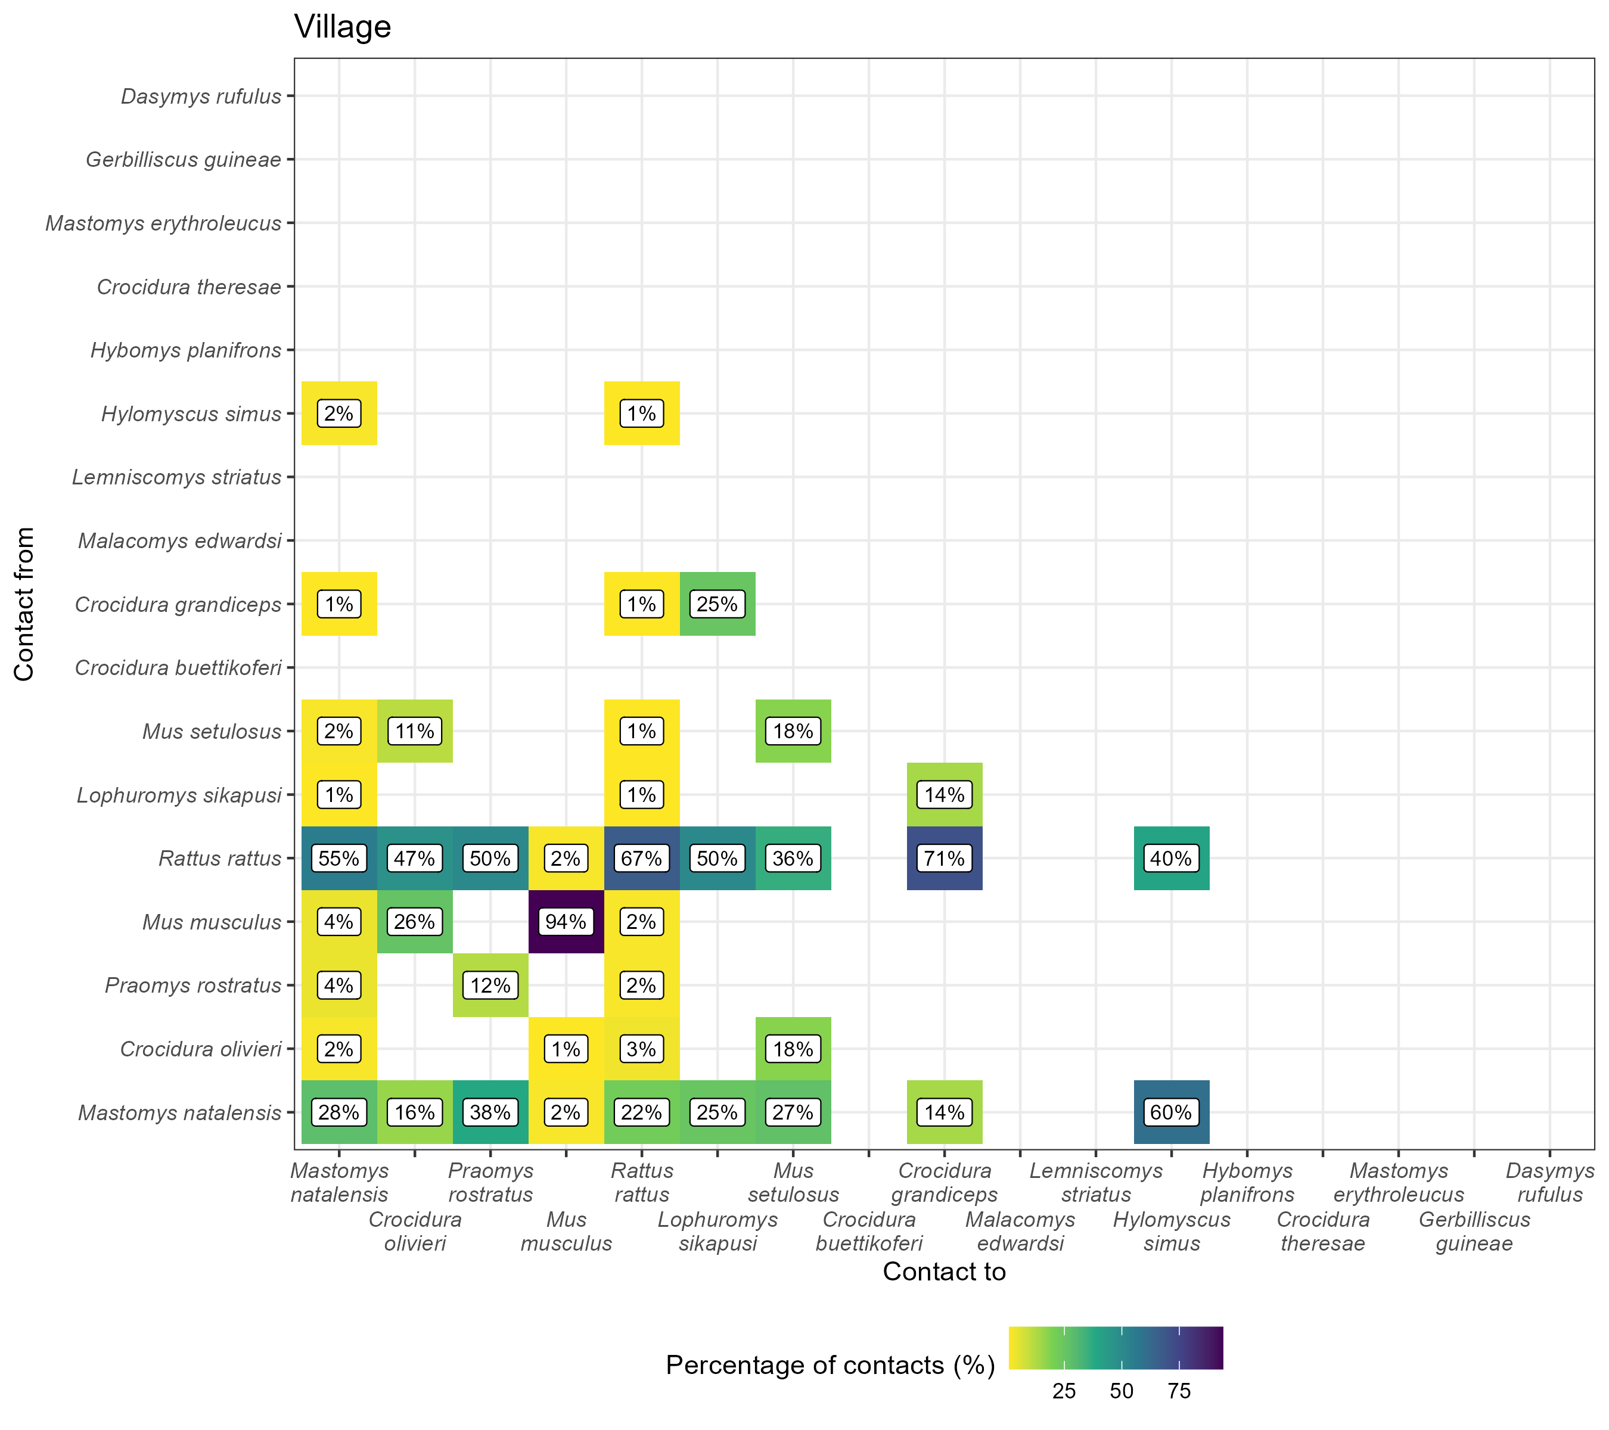

Supplementary Figure 4.2: The proportion of contacts between individual small mammals in village land use. Darker colours indicate increasing proportions of observed contacts to a species (Contact to) from named species (Contact from). Numbers in the cells correspond to the proportion of contacts to a species from a named species. For example, 31% of all contacts to Mastomys natalensis are from other M. natalensis while 44% of contacts are from Rattus rattus. Percentages sum to 100% in the Contact to axis, while they may exceed 100% in Contact from. Species are ordered by the total number detected in this study.

## Supplementary Figure 5

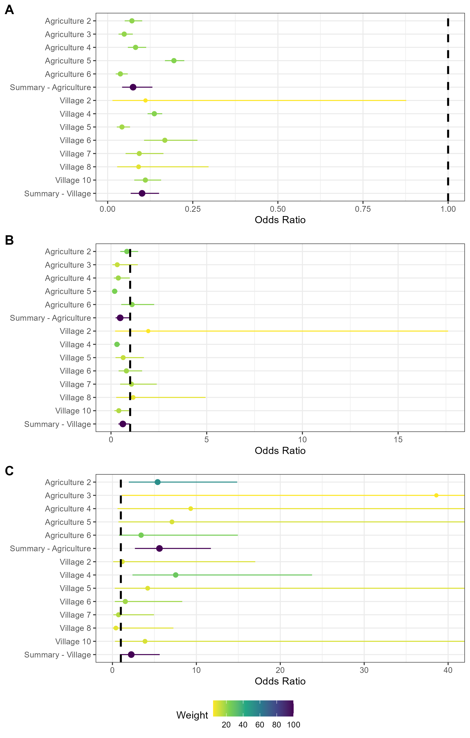

Supplementary Figure 5.1: Random effects meta-analysis of ERGM network models reporting the odds of a contact being observed for M natalensis for the first sensitivity analysis by changing the buffer radius to 15m. A) The odds ratio of a contact being observed for M. natalensis in Agricultural or Village land use types. The finding of reduced odds of an observed edge is consistent with the main analysis (buffer radius = 30m). B) The odds ratio of a contact being observed between M. natalensis and an individual of a different rodent species. The finding of reduced odds of an interspecific edge is consistent with the main analysis. C) The odds ratio of a contact being observed between M. natalensis and another M. natalensis. This finding of increased odds of observing an intraspecific contact is consistent with the main analysis.

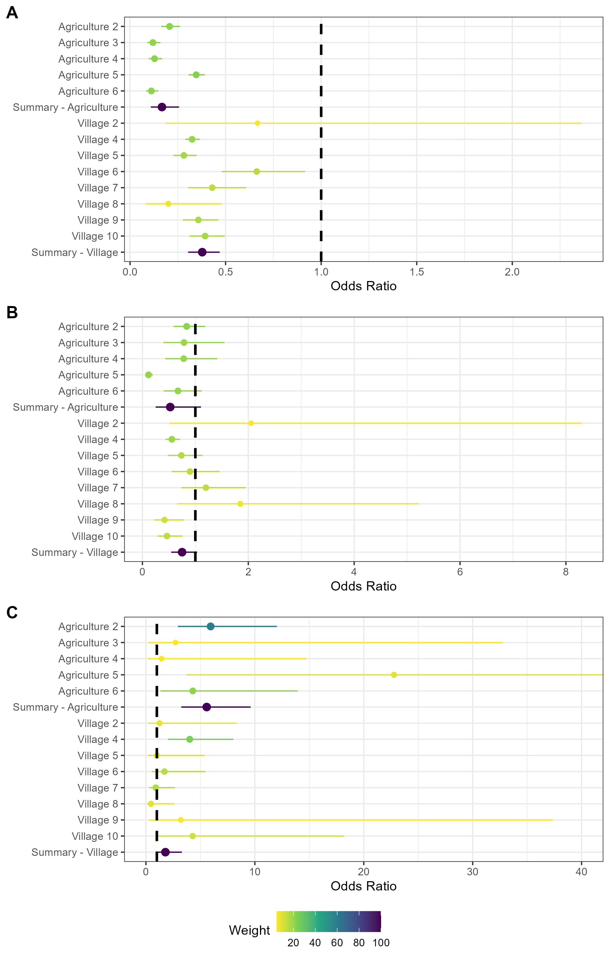

Supplementary Figure 5.2: Random effects meta-analysis of ERGM network models reporting the odds of a contact being observed for M natalensis for the second sensitivity analysis by changing the buffer radius to 50m. A) The odds ratio of a contact being observed for M. natalensis in Agricultural or Village land use types. The finding of reduced odds of an observed edge is consistent with the main analysis (buffer radius = 30m). B) The odds ratio of a contact being observed between M. natalensis and an individual of a different rodent species. The finding of reduced odds of an interspecific edge is consistent with the main analysis. C) The odds ratio of a contact being observed between M. natalensis and another M. natalensis. This finding of increased odds of observing an intraspecific contact is consistent with the main analysis.